**ELECTRONIC DISPENSING TOOL MANUAL**

**TRAINING MANUAL/USER GUIDE**

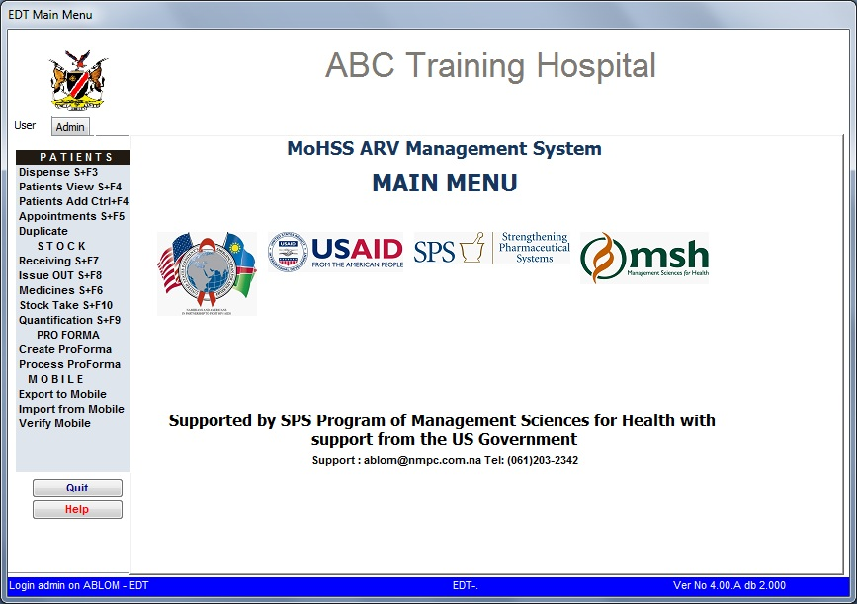

Blom Abraham

Mwinga Sam

Muthiani Victor

March 2012





Systems for Improved Access to Pharmaceuticals and Services

Management Sciences for Health

4301 North Fairfax Drive, Suite 400

Arlington, VA 22203 USA

Phone: 703.524.6575

Fax: 703.524.7898

E-mail:

This user manual is made possible by the generous support of the American people through the U.S. Agency for International Development (USAID), under the terms of Cooperative Agreement #AID-OAA-A-11-00021. The contents are the responsibility of Management Sciences for Health and do not necessarily reflect the views of USAID or the United States Government.

**About SIAPS**

The goal of the Systems for Improved Access to Pharmaceuticals and Services (SIAPS) Program is to assure the availability of quality pharmaceutical products and effective pharmaceutical services to achieve desired health outcomes. Toward this end, the SIAPS result areas include improving governance, building capacity for pharmaceutical management and services, addressing information needed for decision-making in the pharmaceutical sector, strengthening financing strategies and mechanisms to improve access to medicines, and increasing quality pharmaceutical services.

This document does not necessarily represent the views or opinions of USAID. It may be reproduced if credit is given to SIAPS.

**Acknowledgement**

Hare ram Bhattarai who produced the original Dispensing tool.

The Namibia team: Abraham Blom, David Mabirizi, Victor Sumbi and Samson Mwinga.

**Recommended Citation**

This user manual may be reproduced if credit is given to SIAPS. Please use the following citation.

Mwinga Samson, Blom Abraham and Sumbi Victor 2012. *Electronic Dispensing Tool: User’s Manual.* Submitted to the U.S. Agency for International Development by the Systems for Improved Access to Pharmaceuticals and Services (SIAPS) Program. Arlington, VA: Management Sciences for Health.

**Table of Contents**

Acronyms v

Overview 6

CHAPTER 1: GETTING STARTED 9

CHAPTER 2: PATIENT MANAGEMENT 13

A. Adding New Patients 13

B. Patients View 17

**1.** **To update patient information:** 19

**2.** **To view patient’s history** 20

C. Dispense 21

**1.** **To Dispense** 23

**2.** **Viewing the history** 27

**3.** **Making Changes to the Patient Record** 28

**4.** **Receiving** 29

5. **Adding a new patient** 30

D. Appointments 34

CHAPTER 3: STOCK MANAGEMENT 37

A. Receiving 37

B. Issue OUT 39

C. Medicines 42

**To view a medicine**: 43

**To delete a medicine** 46

D. Stock Take 46

E. Quantification 48

CHAPTER 4: MOBILE DISPENSING 50

1. Preparing scanner for Outreach/IMAI 50

1.1 Loading data on scanner 50

1.2 Dispensing on Mobile Scanners 56

1.3 Transferring Dispensing Data to computer 60

CHAPTER 5: REPORTS 68

CHAPTER 6: ADDITIONAL INFORMATION 70

A. Printer Setup 70

B. Changing a patient record 72

C. Processing a pro-forma 76

# Acronyms

|  |  |
| --- | --- |
| AIDS | Acquired Immunodeficiency Syndrome |
| ART | Antiretroviral Therapy |
| ARV | Antiretroviral medicine |
| EDT | Electronic Dispensing Tool |
| FTP | File Transfer Protocol |
| HIV | Human Immunodeficiency Virus |
| MSH | Management Sciences for Health |
| NDB | National Database |
| PEP | Post Exposure Prophylaxis |
| PMTCT | Prevention of Mother To Child Transmission |
| RDS | Remote Desktop Support |
| SIAPS | Systems for Improved Access to Pharmaceuticals and Services |
| SQL | Structured Query Language |
| USAID | United States Agency for International Development |

# Overview

The Electronic Dispensing Tool (EDT) formerly known as the Antiretroviral Dispensing Tool (ADT) is a SQL based software, a practical tool designed to help pharmacy staff providing Antiretroviral Therapy (ART) with patient and stock management and producing relevant data required for quantification at pharmacy level, patient adherence monitoring, facility adherence level and outreach patient management.

The system can be used for patient management, management of stock and producing reports. For patient management:

* Dispensing and labeling of medicines
* Appointments
* Tracing patients who missed appointments
* Keeping patient profiles and history
* Tracking patient adherence through pill counts
* Outreach patient management

For stock management:

* Stock taking
* Receiving of stock
* Dispensing history per medicines
* Tracing of medicines to patients
* Stock status report
* Quantification

**Systems requirements**

To operate the software, the following system is required:

* Core i3, Core i5 or Core i7
* 4 GB MB RAM
* 320 GB Hard Drive
* Windows XP Pro SP3; Windows 7 preferred
* Microsoft Office 2007 Professional with SP3
* MS SQL Server 2008 Express

Uninterrupted Power Supply

* The system must shut down in proper fashion to avoid data corruption.
* Therefore, a minimum of 1 KVA UPS is required.
* Hand held scanners

**Installation**

All installations will be done by the information systems administrator.

In the event that installation should be done at facility level, it will be done remotely using the MTC network via RDS and the installation files will be send via FTP software (FileZilla).

**General Information**

Backup

* The system does backup on daily basis on the hard drive during the lunch hour.
* Besides the automated backup, users are still requested to do backups on the memory stick.
* Users are required to keep the memory stick off-site in case of fire or theft of the computer.
* Thirdly, ART Logistics Pharmacist and/or the Information Systems administrator will backup data on the central national database (NDB) server by using 3g modems.
* Memory sticks should be submitted to the Information Systems administrator every month for updating of Antivirus and systems updates

# CHAPTER 1: GETTING STARTED

To start the Electronic Dispensing Tool, double click the icon (Figure 1.1) placed on the desktop.

**Figure 1.1**

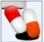

Dispensing Tool icon on desktop

The Logon Screen (see Figurer 1.2) will appear

**Figure 1.2**

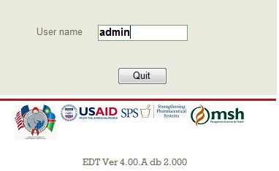

Enter the username and press ENTER. The password line will now appear (see Figure 1.3).

**Figure 1.3**

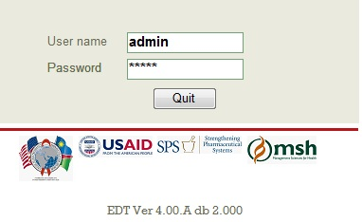

Enter your password and press ENTER. The system will remind you to do your stock taking. If stock taking was not done, it will remind you that stock taking is overdue and by how many days (see below). If stock take were done it will remind you how many days left before the next stock take is due. Click “OK” to access the main menu.

**Figure 1.4**

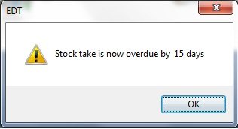

The system checks statuses of patients on every start-up. If a patient is late by 30 days since last appointment, their status will be changed to Lost during this process. This process also changes the statuses for Transferred-In to Active, Lost to LTFU and Restart to Active. See Figure 1.5. When Yes is clicked on this window, a PDF document will be opened with all the changes made, if NO is clicked the system will proceed to the main screen.

**Figure 1.5**

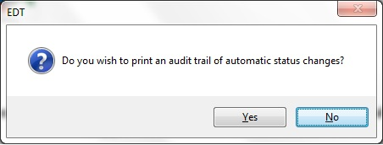

The main menu of the tool will appear (see Figure 1.6).

**Figure 1.6**



Menus at a glance:

***Dispense S+F3 –*** Dispense menu is used to dispense medication to a patient, script maintenance and also switch patient regimen. A patients’ status can also be changed from here.

***Patient View S+F4 -*** Patient view menu is used to view or find a patient and to edit or update patient’s information. This menu can also be used for patient credentials look up.

***Patient Add Ctrl+F4 -*** Patient Add menu is used to add new patients onto the system, new patients started or transferred patients,

***Appointments S+F5-*** This menu option is used to view appointments and to check patients who did not come for appointments. Appointments can be viewed and printed

***Duplicate –*** Here you manage your duplicate patients as well as un-mark patients wrongly marked at duplicate.

***Receiving Stock S+F7 -*** This menu option is used when receiving stock from the supplier or CMS. This menu is also used to receive stock from other facilities.

***Issue OUT S+F8 –*** This menu is used to issue stock out. This can be to IMAI sites, wards or other facilities.

***Medicines S+F6 –*** The medicine menu is used to manage your medicines; check your stock levels and quantification.

***Stock Take S+F10 –*** Is used to do stock takes and update your stock levels.

***Quantification S+F9 –*** This is used to check your quantifications at a glance for planning purposes.

***Create ProForma -*** This is used to create pro-forma invoices or pick slips for medicines dispensed to IMAI sites.

***Process ProForma –*** This menu is used to process pro-formas that have returned in order to update patient details and stock quantities.

***Export to Mobile –*** this menu is used to load files onto the mobile device for outreach dispensing; it is also used to transfer data back from the device and do to the verification of mobile dispensing.

To exit the system, click on “Quit”

# CHAPTER 2: PATIENT MANAGEMENT

## A. Adding Patients

The form below is used to add patients who do not have a pharmacy record on the facility’s EDT; (i) patients starting treatment today, (ii) patients transferred from another hospital and (iii) in-transit patients.

Using the mouse, point to the “Patients Add Ctrl+F4” option on the main menu and click once. The screen as shown below (Figure 2.1) will appear.

**Figure 2.1**

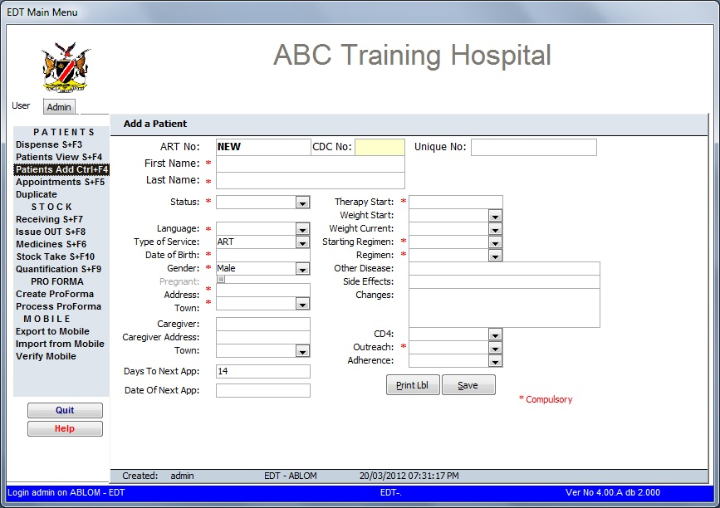

The ART No box is for the ART pharmacy number and its default value is “NEW”. This number is automatically generated by the computer.

Enter the CDC number (the old patient registration number) in the CDC No box. Press “ENTER” and the cursor moves to the right at “Unique No”, this is the 12 digit number assigned to the patient at ART registration and it is usually on the patient’s blue file (Patient Care Booklet).

After you have entered the information required in each box, press enter to get to the next box.

***Note: when opening this screen, the cursor is automatically on the “CDC No:” box.***

Complete the form as it appears on the screen (see Figure 2.2).

**For new patients:**

1. Enter the “CDC No:” this number will appear blue on the screen. Press ENTER.
2. Enter the patients’ unique number as it appears on the passport on the right hand of the “New” box. This number will appear red on the screen. Press “enter”.
3. Type the patient’s first name and press “enter” and type the surname (last name) and press “enter”.
4. ***Patient’s status***. The status “active” should be selected from the drop down arrow.
5. ***Status Changed***: will automatically change to today’s date.
6. ***Language***. The patient’s preferred language should be selected. The language selected is the language that will appear on the labels. Language is compulsory, without the language, the labels will not print.  
   To select a language, using the mouse, press the arrow next to language, scroll down to the desired language and click. You can also select a language by typing in the language box the first letters of the language and selecting the correct one. For example, to choose English, type “eng” and the language correlating with the letters will appear in the box. Press ENTER.
7. ***Type of Service***: Select the type of service from the drop down arrow on the right, (either ART, PEP, or PMTCT)
8. ***Date of birth.*** This is compulsory. Enter the date of birth in the format dd/MM/yyyy. (E.g. 15/10/1960).
9. ***Enter the gender***. Type “f” for female and “m” for male or select from the drop down arrow on the right. If a female patient is entered, the pregnancy box will be activated and if the patient is pregnant, click in the box.
10. ***Address***: enter patients’ physical address and press ENTER, select the town from the drop down arrow on the right and press ENTER. This applies for the ***Caregiver*** as well.
11. ***Therapy Start*** – when entering a new patient, enter the therapy start date (i.e. the date that the entry is being made). If the patient is on ARVs already, enter the date the patient started treatment.
12. Enter the patient’s weight, the regimen the patient is started on.
13. ***Regimen***. Enter the regimen code (see list of regimen codes in annexure 1). If the patient’s regimen does not appear on the code list, click on the arrow on the regimen box and scroll down to the desired regimen and press enter.
14. ***Outreach***. Select the facility that the patient belongs to. If the patient belongs to this site, select your site’s name otherwise select the correct outreach site from the drop down menu. This is important as it will allow you to prepare for all the patients selected for that outreach.
15. Enter all other relevant details and when finished, and click on save. At this stage, the pharmacy ART number will appear at the ART left hand side box.

**Figure 2.2**

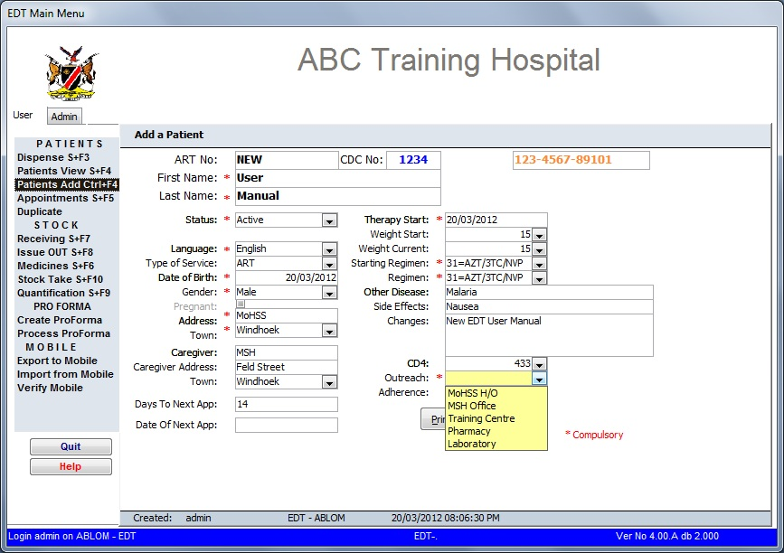

**For transfer-in patients:**

1. Follow instructions as for new patients.
2. On the status box, select *“Transfer IN”* from the drop down list and press enter. The system will prompt you to enter the patient’s existing ART number followed by the existing CDC and Unique numbers (see Figure 2.3)
3. ***Therapy Start*** – enter the date that the patient started treatment in the format dd/mm/yyyy (e.g. 24/08/2005)

**Figure 2.3**

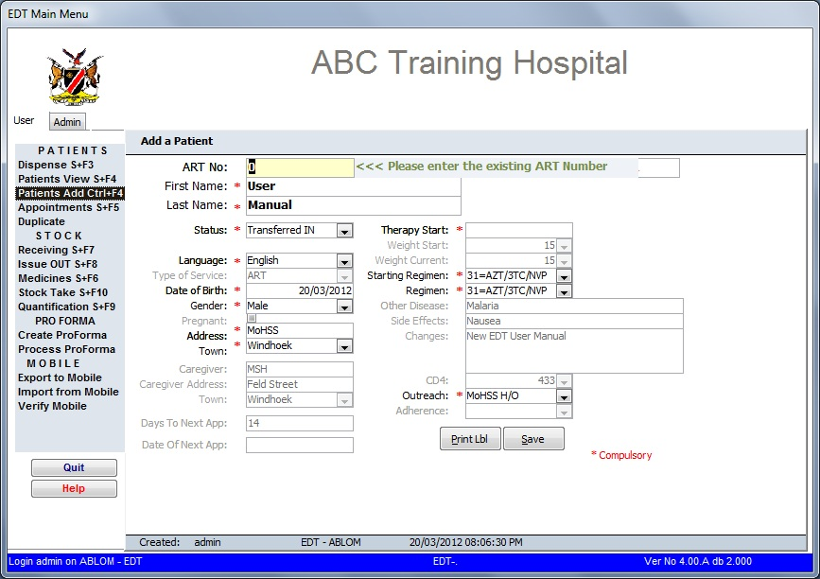

Once all patient details have been added, save the record by pressing “Save” box. The screen below (Figure 2.4) will appear. Press “OK” to print the passport label.

**Figure 2.4**

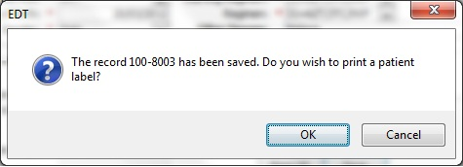

The Patient label is affixed to the patient’s passport and the ART number is used in future for dispensing and to retrieve the patient’s information.

**Figure 2.5**

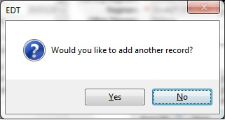

Another record can be added by clicking yes (Figure 2.5).

## B. Patients View

Patient view is the screen that is used to view or find a patient and to edit or update patient’s information. This screen can also be used if the patient has forgotten their pharmacy ART number.

To get to this screen, you select the “**Patient View**” on the menu on the left using the mouse and click on it (Figure 2.6).

**Figure 2.6**

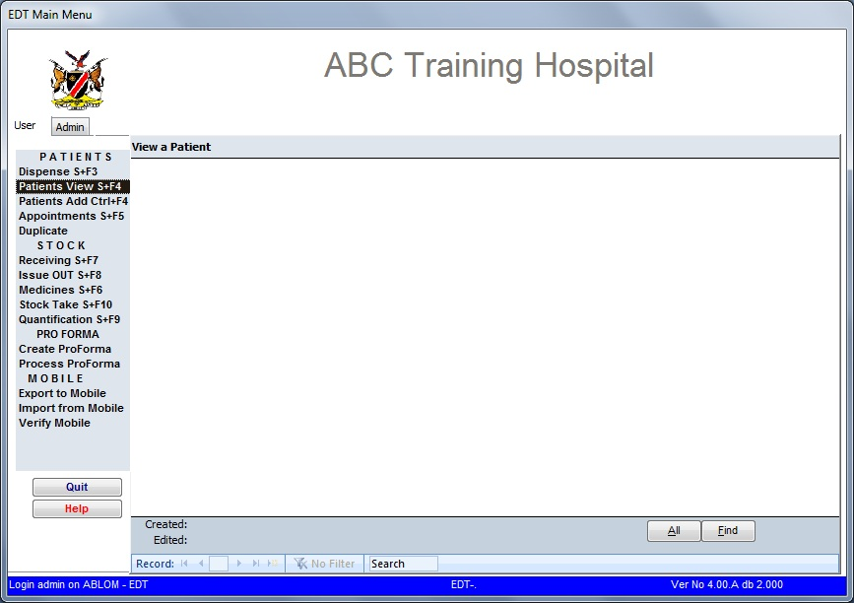

On this screen, either click on ‘All’ to view all patients or click on ‘Find’ to search for a particular patient by ART number, CDC number, Unique number or Last Name.

**Option 1 - All**

Shows all patients on the system, and you browse with the arrows on the bottom to the next patient.

**Figure 2.7**

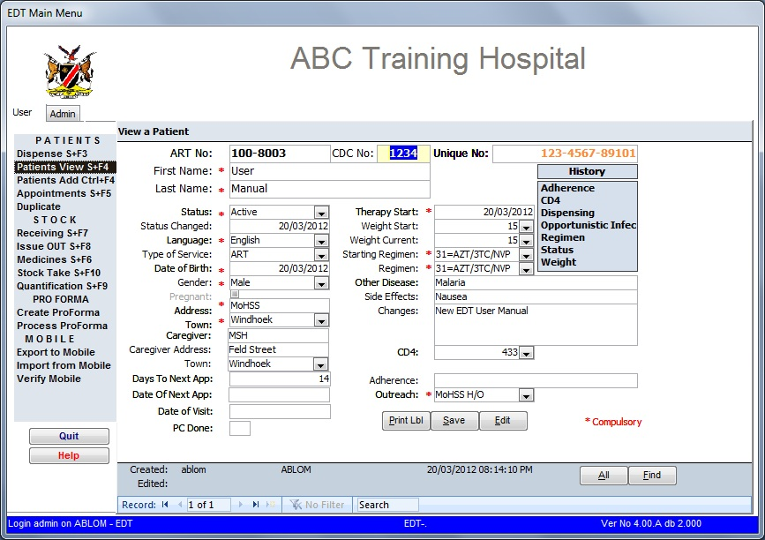

Use the arrows at the bottom of the screen where the record is showing to scroll from patient to patient.

**Option 2 – Find**

**Figure 2.8**

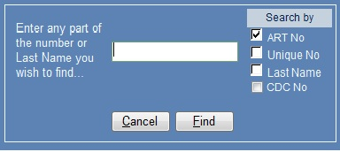

* Select the ART number or unique number or Last name or CDC number to search for a patient.
* Select your search criteria on the right and then enter your information in the white empty box, then click on ‘Find’ as displayed in Figure 2.9.

**Figure 2.9**

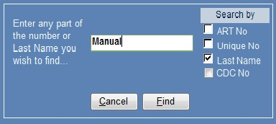

* Press find or enter twice

**Figure 2.10**



1. **To update patient information:**
   1. Select the patient using any of the above methods.
   2. Press the “Edit” button at the bottom of the screen. The screen will turn yellow and the pop-up information box will appear (see figure 2.11 and figure 2.12). Click OK.

**Figure 2.11**

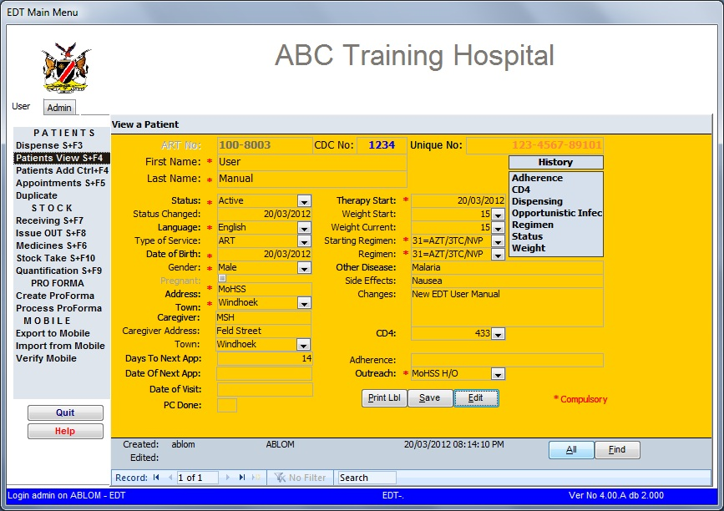

**Figure 2.12**

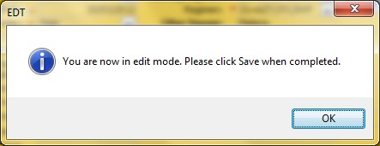

* 1. Select the field you require to update
  2. Record changes that have been made on the “Changes” field e.g. *regimen changed on 17/10/2005*
  3. Press the “Save” button at the bottom of the screen to save the changes. Confirmation that the record has been changed will appear and the screen will turn back to normal colour.

1. **To view patient’s history**
   1. Select the patient using one of the options discussed above.
   2. Click on any of the history buttons displayed on the right of the screen   
      (see Figures 2.7 and 2.10).
      1. **Adherence** – gives all the recorded adherence changes relating to the selected patient. It provides the adherence graph for the patient.
      2. **CD4** – gives a record of all CD4 values entered on this patient’s record.
      3. **Weight** – gives a record of all the weight changes relating to the selected patient.
      4. **Opportunistic Infections** – Allows seeing the history of other infections that the patient has experienced with the start and ending dates.
      5. **Regimen** –gives all the regimen changes relating to this patient. For example moving from D4T30/3TC/NVP to AZT/3TC/NVP will be recorded including the date of the regimen change and the person effecting the change.
      6. **Status** – this refers to the patient being changed from one status to another. For example IN Transit to Active
      7. **Dispensing** - For example the patient’s dispensing details appear when you select Dispense (the date of dispensing, the medicines dispensed, quantity dispensed, any dispensing comments and the script number)

PLEASE NOTE, FOR YOU TO SEE ANY OF THE ABOVE; THERE MUST HAVE BEEN CHANGES THAT WERE RECORDED. IF THERE ARE NO CHANGES, THE FIELDS WILL REMAIN BLANK.

## C. Dispense

The **Dispense** screen (Figure 2.13a) is used to dispense medication to a patient, script maintenance and also switch patient regimen.

The screen can be accessed by clicking the “Dispense” option from the menu.

**Figure 2.13a**

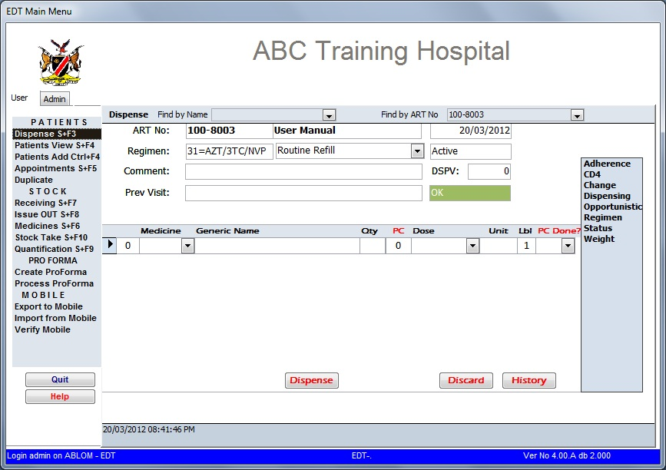

The history shortcuts (see Figure 2.13a) appear as soon as a patient is selected and is to the right for the user to view the patient’s dispensing history.

The comments line is for entering any dispensing related comments. The comments will also show on the dispensing history/details screen. In the screen under “Viewing the History” below, the comments entered were “new patient”.

The previous history field displays the comments entered at the last patient’s visit (the visit preceding the current)

The DSPV stands for “Days since Previous Visit”. This shows the number of days since the patient last visited the facility. The box below that (showing green with OK on the screen above) will display OK if the DSPV falls within the acceptable range. It will show red and display the number of days missed when applicable (as shown below Figure 2.13b)

When the DSPV button is red, the option to add a date of visit is appear. This date can be obtained from the patient’s passport. If a date is available while patient was in-transit at another facility, please enter the date. This is important for the calculation of adherence.

**Figure 2.13b**

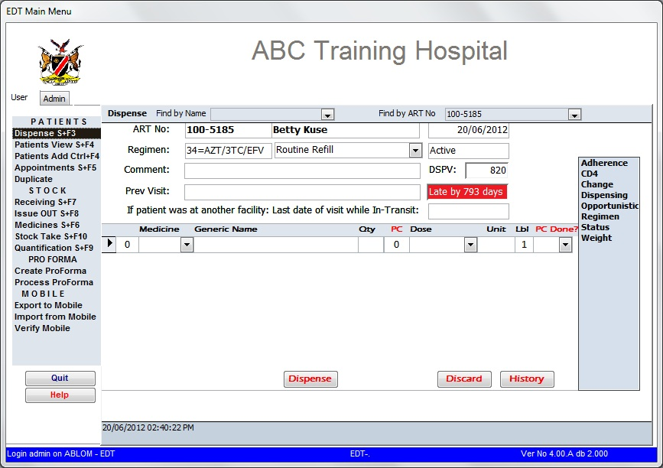

1. **To Dispense**
2. Use the **SURNAME** of the patient or their pharmacy ART number to find a patient. Enter a portion of the name or number and select the appropriate patient from the drop down menu. ***When using the ART number, remember to start with the facility prefix!***

To select the patient from the drop down menu, point to the required patient and click.

The patient information will appear as shown below (see Figure 2.14) showing the patient name and surname, pharmacy ART number, current date and regimen.

The screen will also show “routine fill” as a default for all “old” patients and Transfer In’s and “start” as default for all new patients. To change this, press the arrow next to the “start” box, a drop down menu will appear. Select the reason for the transaction. After entering the comments, press enter.

**Figure 2.14**

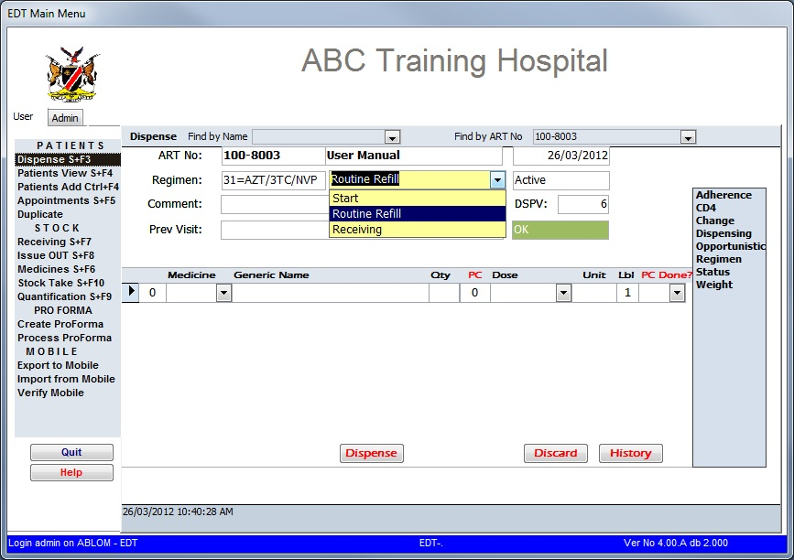

1. ***Selecting medicines (See Figure 2.15 below).***
2. **Figure 2.15**

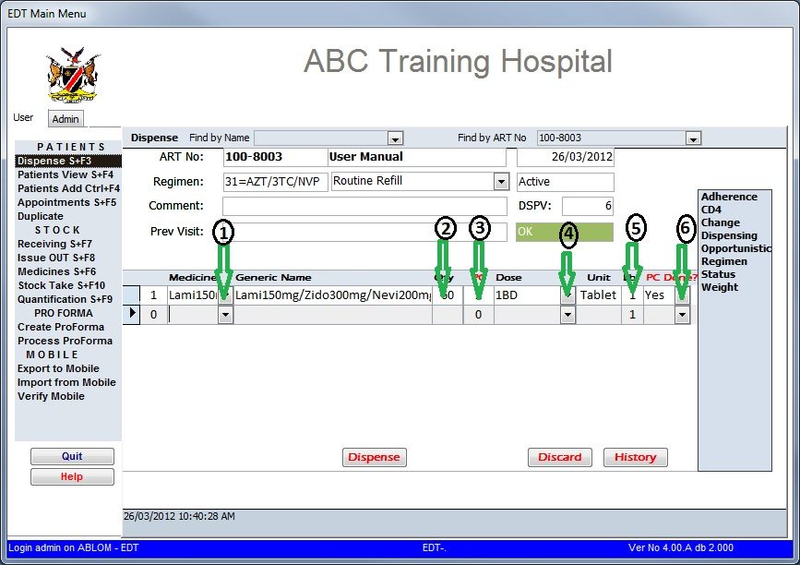

1. The cursor will be on the medicine column of the screen. Use the mouse to click on the arrow next to the medicine box. A drop down menu will appear. Select an item from the menu by pointing to it using the mouse or scrolling to it using upwards or downward arrows on the keyboard. Once an item has been highlighted, click or press enter.

The name of the medicine including strength will appear on the next box.

1. Press enter and the cursor will be on the quantity (Qty) column, type in the required quantity and press enter.
2. Enter the pill count of the tablets the patient has brought with. The PC Done column will automatically change to Yes if a figure is punched in the PC column. If the pill count is zero you have to select Yes in the PC Done column to move on to the next line.
3. The default dosage will be highlighted. If a different dosage is required, use the arrow next to the box to activate the drop down menu and select from the drop down menu the required dosage, then presses enter.
4. Press enter again to highlight the number of labels required. The default number of labels is one (1), if more than 1 label is required for the medicine, type the required number and press enter. If no labels are required, type zero in the LBL field.
5. Once you have selected Yes for zero pill count and press enter an Adherence Screen (Figure 2.16) will pop up showing the adherence of that specific medicine. The next line (row) will appear and the arrow on the left hand side will point to the empty line (row)

**Figure 2.16**

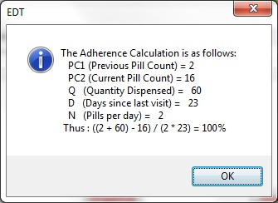

**To Discard Prescription**

After adherence is calculation has been updated and you want to discard dispensing to that patient you can just click on the ‘Discard’ on the dispensing screen. This you will do if a patient is on the wrong regimen and you need change it, or the patient need to be sent for counseling.

**To Reverse a Prescription**

After medicines had been dispensed and you realize an error had occurred, wrong medicines had been dispensed or wrong quantities has dispensed, the prescription has to be reversed. In this process the complete prescription must be reversed and re-dispensed. The following procedures should be followed in order reverse a prescription:

1. Follow the steps to dispense medicine
2. Select Receiving on the type of visit drop down menu and select receiving (Figure 2.14)
3. The complete list of medicines dispensed previously will appear in the dispensing screen (Figure 2.17)

**Figure 2.17**

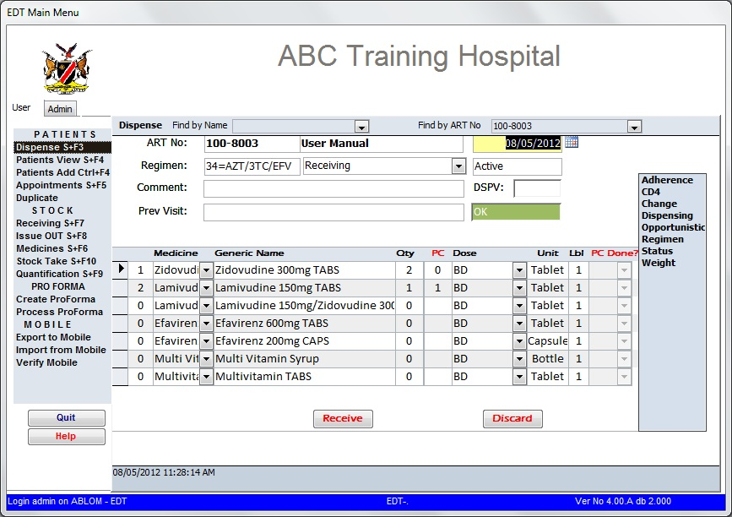

1. Click on ‘Reverse’ to reverse the dispensing record or ‘Discard’ to cancel the operation (Figure 2.17)
2. Confirmation pop-up appear and once confirmed the record will now be reversed, and correct dispensing can now be done (Figure 2.18)

**Figure 2.18**

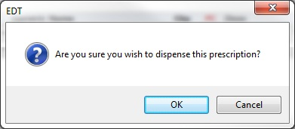

1. Adherence calculation is also reversed, and it will be calculated again with the next dispensing.

**History Button**

This button is used to view dispensing history of a patient. You can view it in the dispensing screen or export it to Excel.

1. Once all the medicines have been selected, click on dispense. The screen will prompt you and ask, “Are you sure you want to dispense this prescription?” Press “OK”.

**Figure 2.19**



1. The screen will then prompt for the next appointment date. Select the required appointment date and press OK. The required appointment date can be selected by either changing the number of days to next appointment or select the required date from the calendar. To select from the calendar, click on the date, calendar will appear, then click on the calendar (Figure 2.20).

**Figure 2.20**

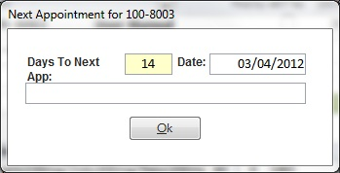

If the appointment falls on a weekend, the system will notify you (figure 2.21) and shift the appointment to the Friday preceding the weekend. Select OK. You can change the date of next appointment if you do not accept the change the system has made.

**Figure 2.21**

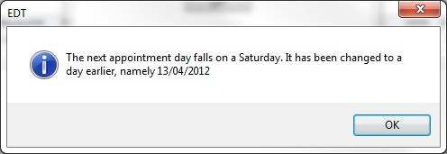

At this stage, the medicines labels will print automatically. An additional tracer label will also be printed. The tracer label is for the dispenser to attach to the patient’s passport.

The dispensing of the prescription is complete. The next script can now be dispensed.

1. **Viewing the history**

The history buttons contains all the history of a selected patient (i.e. adherence, CD4, status, dispensing, weight and regimen). By clicking on the desired option (see Figure 2.14) on the right hand side menu, the patient’s history details appear. Figure 2.22 displays the result of the “Dispensing” button selected.

**Figure 2.22**

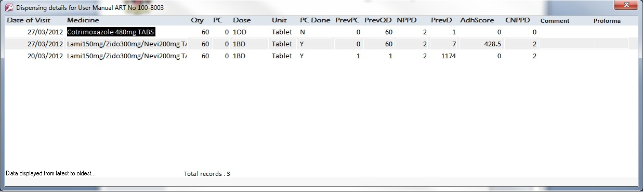

Figure 2.23 shows the adherence records of the patient in graph format. Graph figures are populated as dispensing takes place on a monthly basis.

**Figure 2.23**

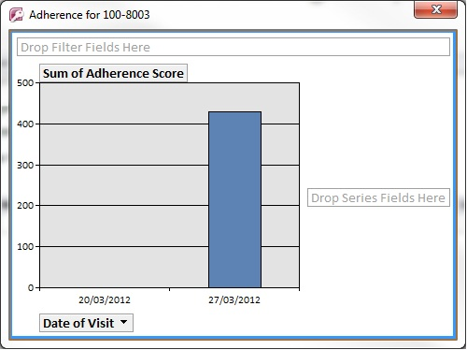

1. **Making Changes to the Patient Record**

Select the “change” option on the right hand side of the screen (see Figure 2.14). A box like the one shown below in Figure 2.24 will appear.

Change the field you wish to update and click Save. A confirmation screen (Figure 2.25) will appear, click OK.

The dispensing screen will come up again blank this time with only the ART number of the patient appearing on the “find by ART No” field. Re-select the patient you have just updated and continue with the dispensing.

To view these changes, select and click on the option you want to view from the menu (Figure 2.14). The changes will appear as shown in (Figure 2.24) and below (Figure 2.25).

**Figure 2.24**

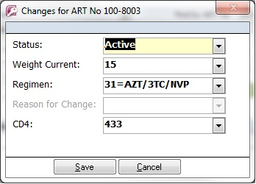

**Figure 2.25**

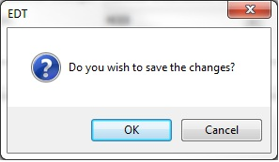

A pop-up screen (Figure 2.26) showing the old and new regimen will appear as well as the user who changed the regimen when you click on Regimen on the right hand menu (see Figure 2.14).

**Figure 2.26**

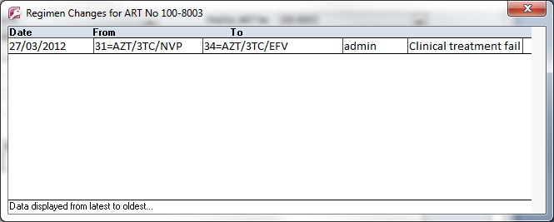

Select the patient again and continue with the dispensing.

1. **Receiving**

This is used to correct dispensing errors. For an example, if Multivitamin Tablets was selected instead of syrup, the mistake can be corrected on the script maintenance.

To correct a script, in the Dispensing menu,

1. Select the patient
2. From the arrow next to routine refill, select receiving (see Figure 2.14). This allows to receiving medication previously dispensed.
3. The system will show you the last dispensing done to the patient. You are just required to click on “**Receive**” and whole dispensing record is reversed and the adherence has also been reversed. Note that you reverse all medicines dispensed on last visit

(Figure 2.27).

The medicine has now been reversed and the history will show a screen like this one – with a negative sign on what has been reversed and “Script Maint” on the notes (see Figure 2.28).

**Figure 2.27**



**Figure 2.28**

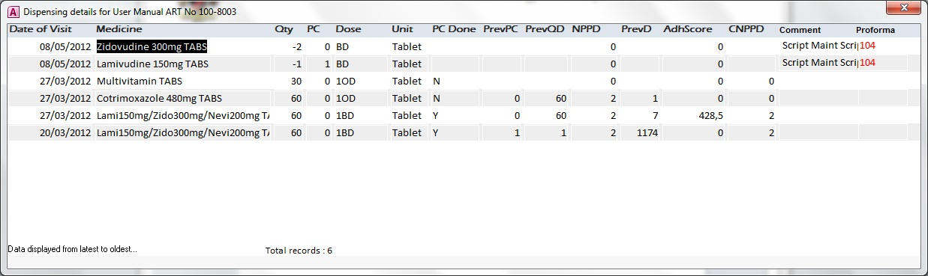

You will notice that it is even possible to reverse dispensing that has been done with pro-forma as well as with the mobile dispensing device at outreach or IMAI sites.

1. **Adding a new patient**

New patients can also be added from the Dispensing Screen.

**To add a new patient:**

1. Enter the patient’s name on the “find by Name” box and press enter. A dialogue box like the one shown below (Figure 2.29) will appear.

**Figure 2.29**

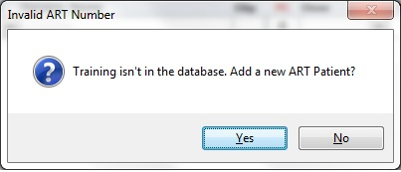

1. Select “Yes”. The “Add a new patient screen” (Figure 2.30) will now appear.

**Figure 2.30**

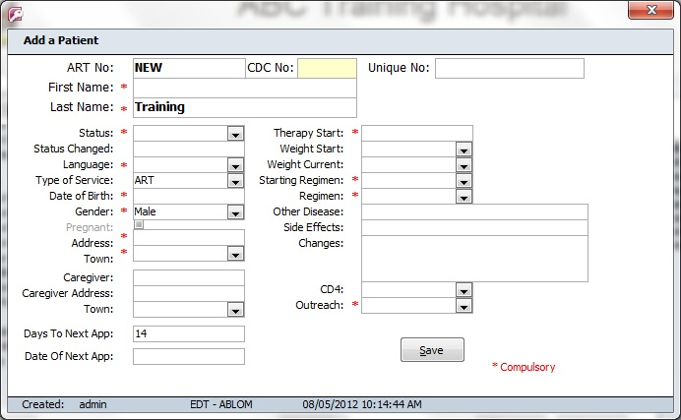

1. Continue to enter the patient details as previously and click the “save” button. The information dialogue box will appear (figure 2.31) with a message that the record has been saved. It will ask if you wish to print a patient label for the patient’s passport. Click “Yes” if you need to print a label otherwise select “No”.

**Figure 2.31**

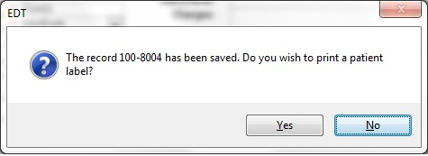

The screen to add another patient from this menu will appear. Click “No” if you are done adding patients or click “Yes” if you wish to add more patients (Figure 2.32).

**Figure 2.32**

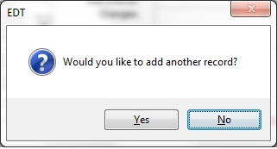

The dispensing screen (Figure 2.33) with the newly added patient details will appear – continue to dispense as usual

**Figure 2.33**

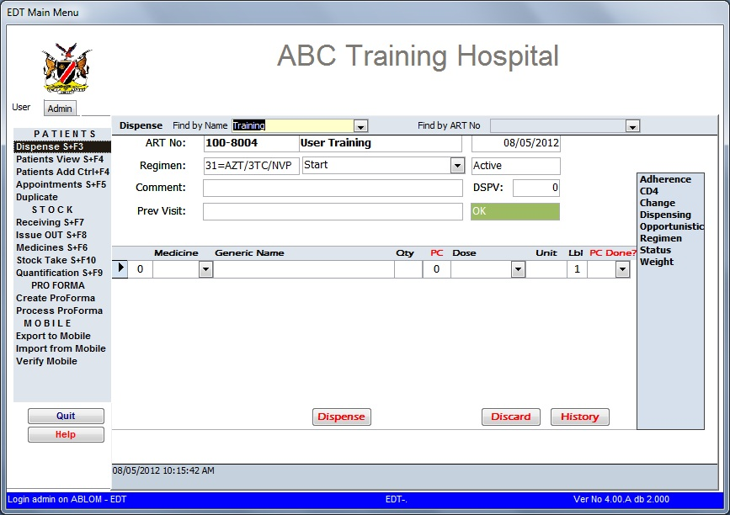

## D. Appointments

This menu option is used to view appointments and to check patients who did not come for appointments. Appointments can be viewed and printed.

To get to the appointment screen, select “Appointment” from the main menu and click once (see Figure 2.34 below)

**Figure 2.34**

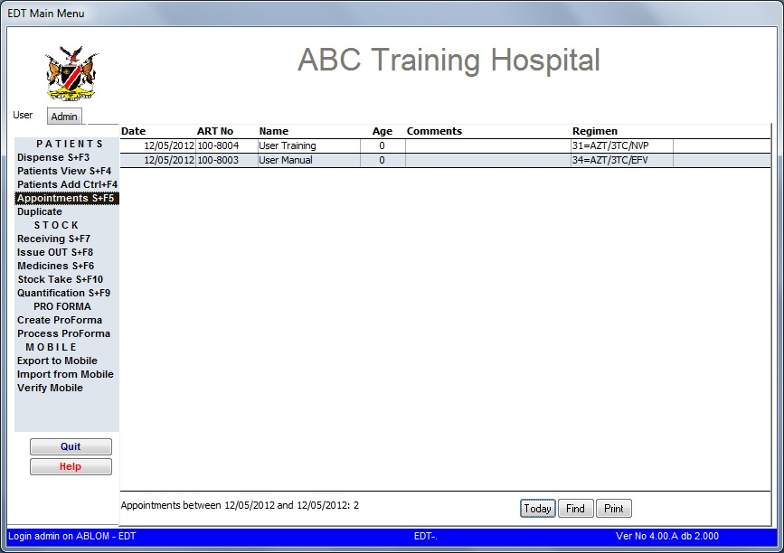

The appointments automatically default to the current date (the day that the appointment is viewed). However appointments for a day/week/month can be selected and viewed.

To select a different appointment date

1. Click on find at the bottom of the screen, a calendar will pop-up (see Figure 2.35).
2. Select the required dates next to the “From” and “To” boxes. Select the status of the patients from the status box and click on “OK”. If only appointments for one day are required, select the same date on the calendars in both “From” and “To” boxes.

Figure 2.35

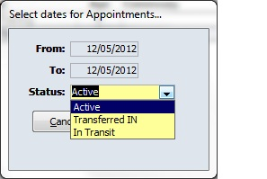

If a range of dates is required, select the first day of the range and click in the “from” box and the last date of the range and click in the “to” box, select the status of the patient (eg. Active, Transferred IN or In Transit) and press “OK”. In the above picture, the range is from 04/02/2006 to 13/02/2006.

The bottom of the screen shows the selected range and the total appointments expected during the selected time.

Once a patient turns up for the appointment, their name is automatically deleted from the appointment list. Patients whose names still remain on the appointment list are those who did not turn up for the appointment. Patients who missed appointments can be viewed per day, week, month or any selected range in the same way that appointments are viewed but they are viewed retrospectively (i.e. appointments missed in March can only be viewed from April onwards).

Again, the list of patients who missed appointments can be printed as explained below

When printing the appointment report, click on “Print” at the bottom of the screen, a small screen will appear (Figure 2.36) which shows you the progress as well as the path where the file will reside. The print out summarizes the report by date and within the date appointments are sorted per regimen and a total for each regimen is given.

**Figure 2.36**

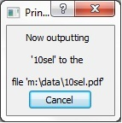

A PDF file will open with the list of appointments as selected. You can either save your document on your computer or you can save it onto memory stick to print it somewhere else (see Figure 2.37).

**Figure 2.37**

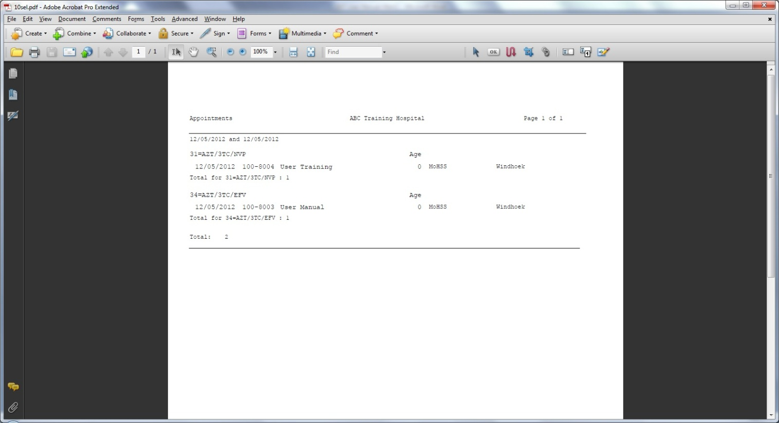

# CHAPTER 3: STOCK MANAGEMENT

Management of stock is done by the following options; receiving, transfers, medicines and stock take on the main menu.

## A. Receiving

This menu option is used when receiving stock from the supplier.

1. On the main menu, select receiving and click once to access the screen (see Figure 3.1).

**Figure 3.1**

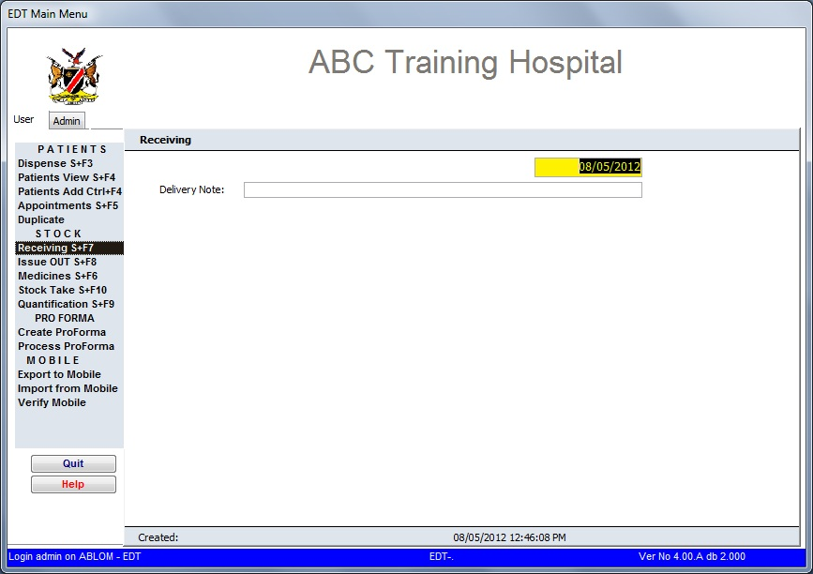

1. Type the delivery note number and press enter. If it is a receipt from another facility, type in the name of the facility and date of receipt and press enter. The screen will prompt for entry of medicines.
2. Select the medicine received from the drop down list and click once.
3. Type in the quantity received and press enter. The quantity for solid oral dosages is per tablet/capsule. The quantities for liquids are per bottle (see Figure 3.2).

**Figure 3.2**

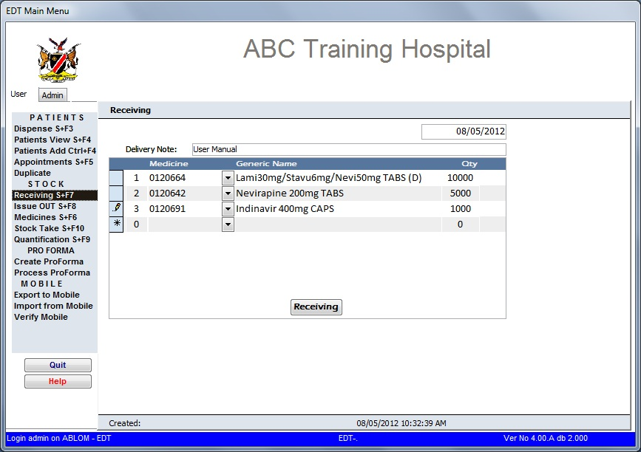

1. Click receiving. The system will ask you to confirm if you wish to receive the stock and also ask you to insert the paper in the printer. Click OK.

**Figure 3.3**

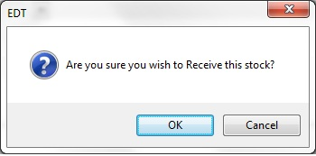

1. A goods receiving note will be generated as shown in figure 3.4 (see Annex 3), which can be printed and filed.

**Figure 3.4**

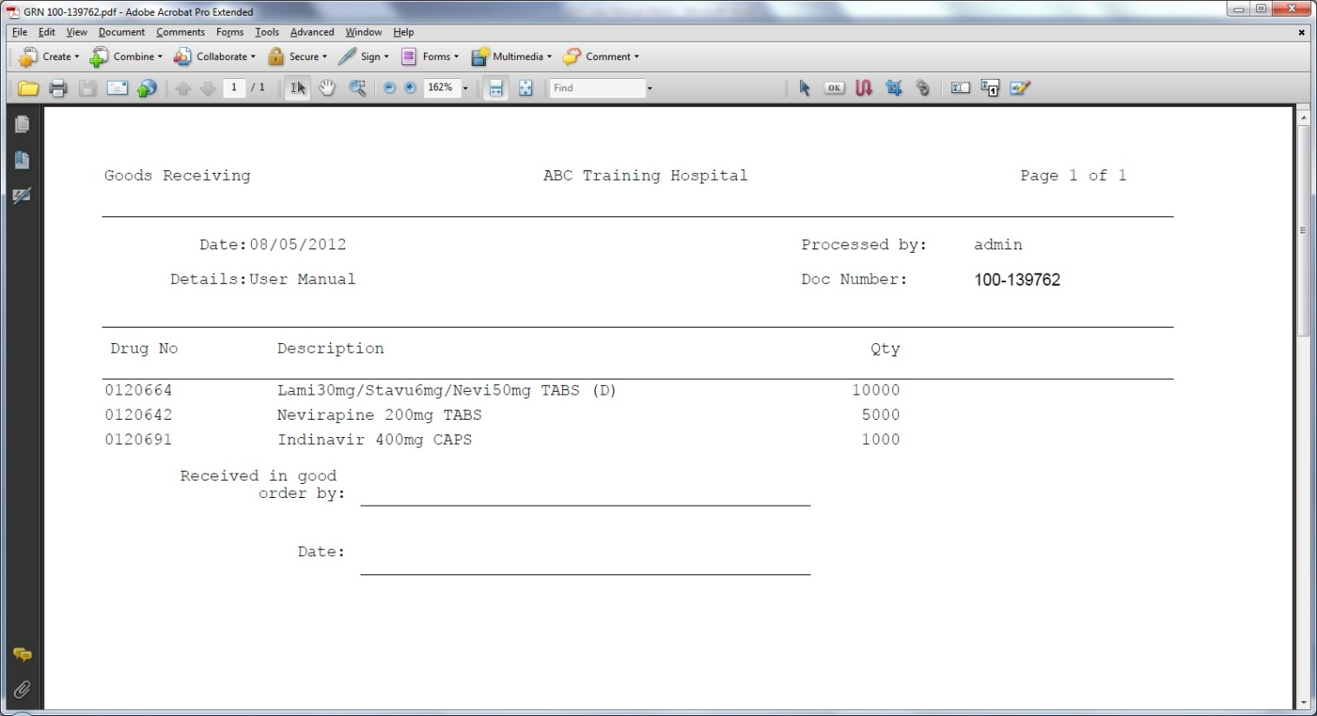

## B. Issue OUT

This is used when issuing stock between facilities or within the facility. Stock that is being issued to PMTCT or Maternity can be issued out as stock transfer. This is also the case for stock issued to another facility.

1. Select Issue OUT on the main menu and click once (see Figure 3.5). The screen like the one below will appear.

**Figure 3.5**

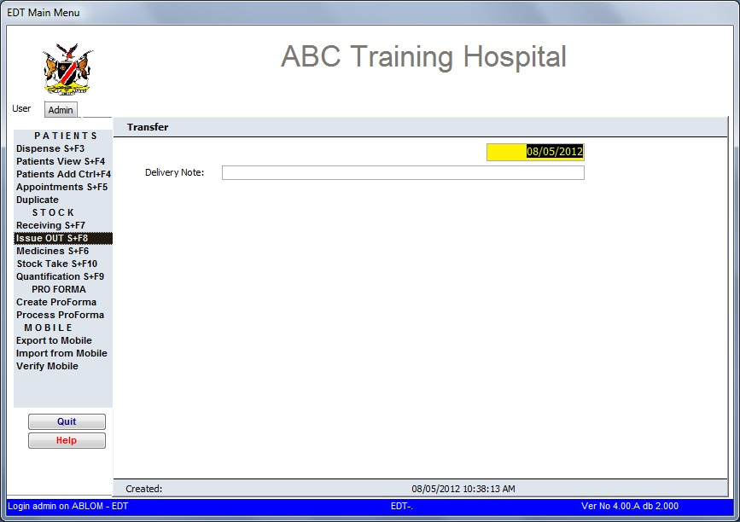

1. Type the name where the goods are being transferred to on the delivery notes box and press enter. For example, if goods are being transferred to Maternity ward, type Maternity ward.
2. Select the medicines you wish to transfer, enter the quantities and press enter. The quantity for solid oral dosages is per tablet/capsule. The quantities for liquids are per bottle. (See Figure 3.6).

**Figure 3.6**

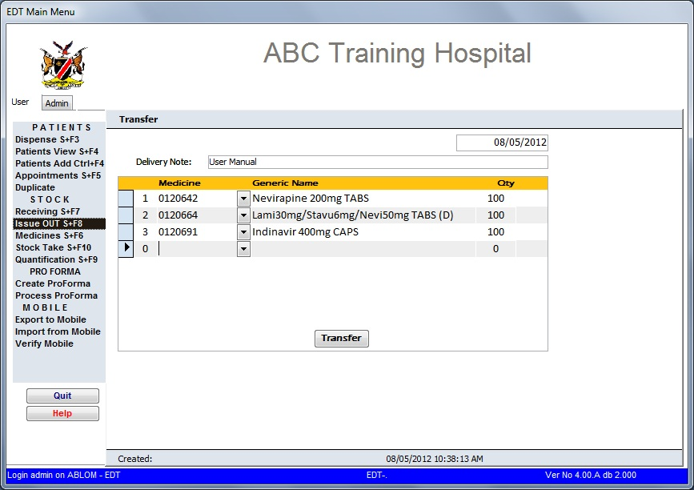

1. Click on “Transfer”. The system will ask you to confirm if you wish to transfer the stock and also ask you to insert the paper in the printer (Figure 3.7). Click OK. A goods transfer note will be generated (see Annex 4).

**Figure 3.7**

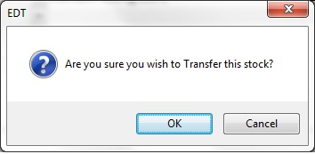

1. A Goods Transfer Note is created in PDF which should be printed in duplicate and sent with the medicines in order for receipt of equipment to be signed by recipient (Figure 3.8).

**Figure 3.8**

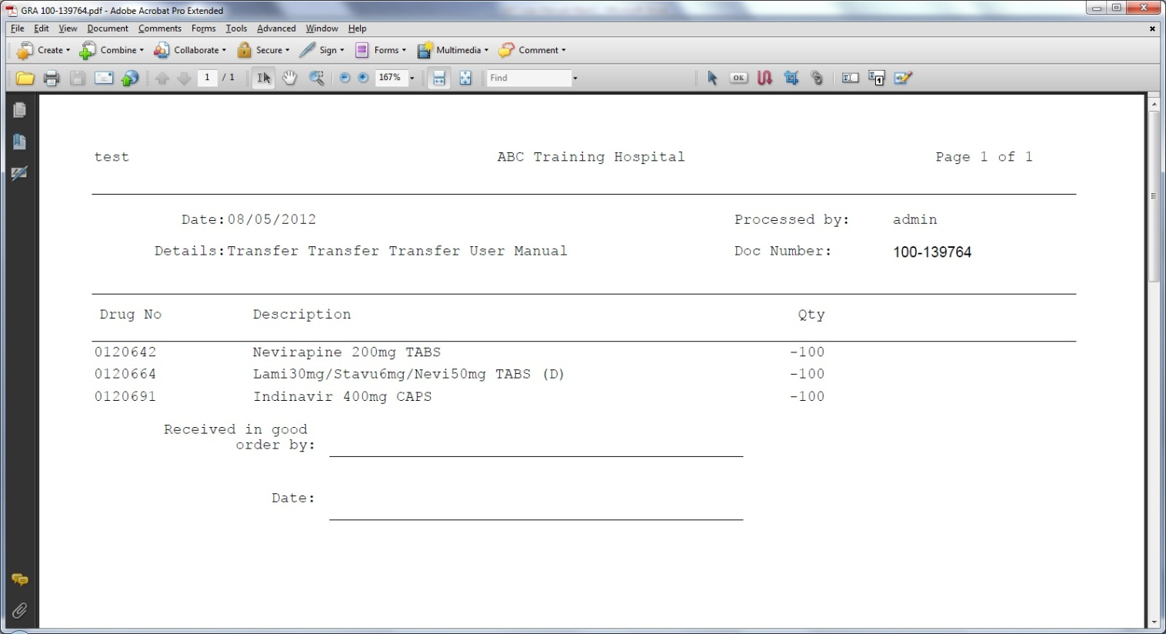

## C. Medicines

This option is used to view medicines or edit medicines.

Select the option by clicking once on it from the main menu (Figure 3.8).

**Figure 3.8**

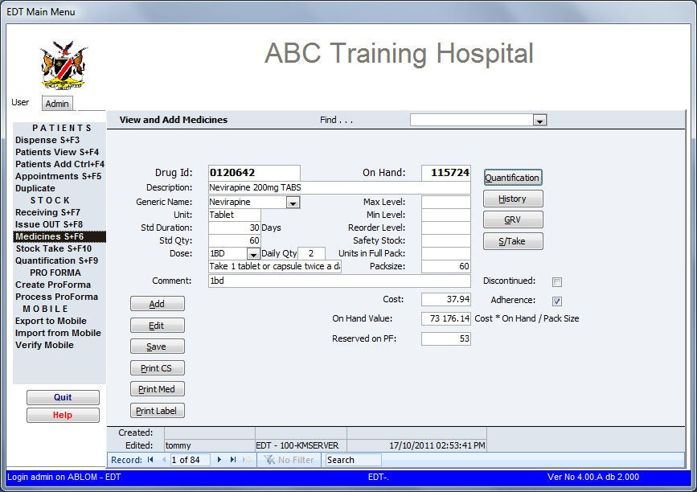

**To view a medicine**:

Type the name of the medicine on the Find box or select the medicine from the drop-down menu and press enter.

* *Drug Id* – refers to the CMS catalogue number
* *On Hand*  – the quantity of the medicine on hand (in stock)
* *History*  – clicking on the history button allows viewing all dispensing history related to  
   the medicine. The dispensing history is summarized per month and it shows the  
   total quantities dispensed in that month plus the cost for that month   
   (see Figure 3.9).

**Figure 3.9**

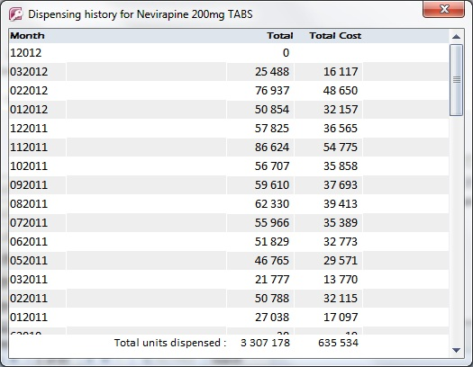

* *GRV* – this allows viewing of all receipts of the medicine. It shows the date, receipt  
   number and quantity.
* *Dispensing* – This is the default. On the bottom box below comments, a detailed description  
   of dispensing records is displayed. This shows the dispensing date, the patient,  
   the unit of issue and the quantity dispensed. This allows for tracing of medicines  
   to the patient.
* *Quantification* – This shows you the recommended reorder quantities for the medicines based on  
   the average monthly consumption (AMC), min and maximum stock. It also  
   shows how many weeks the available stock will last (Figure 3.10).
* *S/Take* – This shows the stock take history (report). It shows the stock take date and the  
   quantity recorded on that date.

Cost parameters are also included at the bottom of the screen. Costs are based on CMS prices and are updated centrally.

**Figure 3.10**

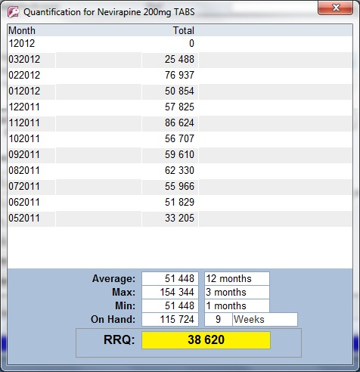

**To add a medicine:**

1. Click on the “**Add**” button.
2. The Add medicine screen will appear (Figure 3.11). Enter all the relevant information.
3. **Drug ID** – enter the medicine code from Central Medical Stores.
4. **Description** – enter the description of the medicine.
5. **Generic Name** – Choose the generic name for the medicine from the drop down menu.
6. **Unit** – enter either tablet for tablets or capsules, or bottle for liquid medicines
7. **Std Duration** – enter the standard duration for the medicine, either 30 days or 60 days.
8. **Std Quantity** – enter the standard quantity normally dispensed.
9. **Dose** – enter the dosages
10. **Pack Size** – this pack size of the container that the medicine comes in.
11. **Adherence** - If the medicine is solid dosage form, please select adherence radio button to enable the pill count for adherence monitoring.
12. After entering all the medicine details, click on **Save** and the record is added.
13. Update the on hand quantity of the medicine by receiving the stock into the system of the medicine you have just entered.
14. Add the medicine to the relevant regimen; the medicine is now available for dispensing in the regimen.

**Figure 3.11**

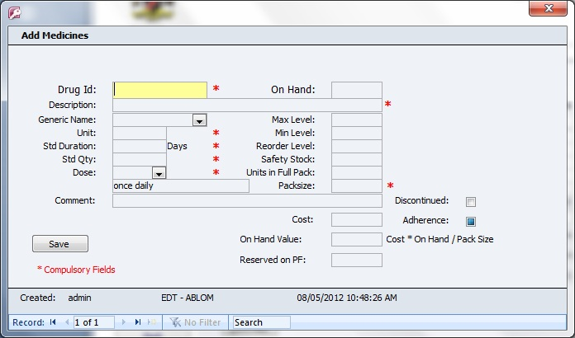

**To delete a medicine**

The system does not allow for any record to be deleted.

If a record is no longer applicable, it can be disabled by checking (√) on the discontinued box. This disable the record but does not tamper with all transactions related to the record.

A discontinued medicine does not appear on the drop down list of medicines in the dispensing, transfers, receiving and stock take screens.

Print CS – This option is used to print the barcode sheet by medicine for use with mobile devices. The document is created in PDF format and can be printed on any laser printer.

Print Med – This option is used to print barcode sheets by regimen for use with mobile devices. The document is created in PDF format and can be printed on any laser printer.

Print Label – This option is used to print pre-printed labels for use at outreach sites and IMAI sites.  
 These labels contain all relevant data except for patient name and date.

## D. Stock Take

The stock take option is used to update the stock levels after a stock take is done.

**Please Note**: Updating stock will permanently change the existing quantities. Do not leave any field as zero “0” unless there is nothing on the shelf!

The option is accessed by clicking once on the ***“Stock Take”*** option on the menu (see Figure3.12)

**Figure 3.12**

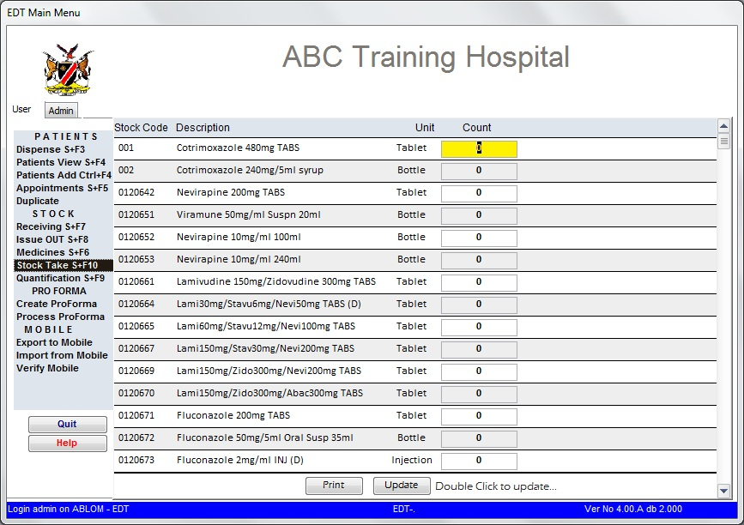

After a stock count has been done, enter the quantities for each item under the column count and once all items have been entered, double click on “update”. A pop-up screen asking for confirmation will appear (see Figure 3.13). Click “OK”

**Figure 3.13**

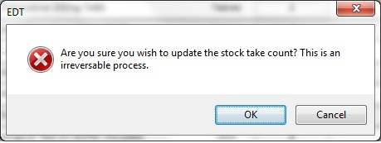

A confirmation box that an update has been completed will appear. Press “OK”. The screen will automatically go to the main menu screen.

## E. Quantification

The quantification menu is used to view the consumption summary and the recommended re-order quantities for each medicine.

Figure 3.14

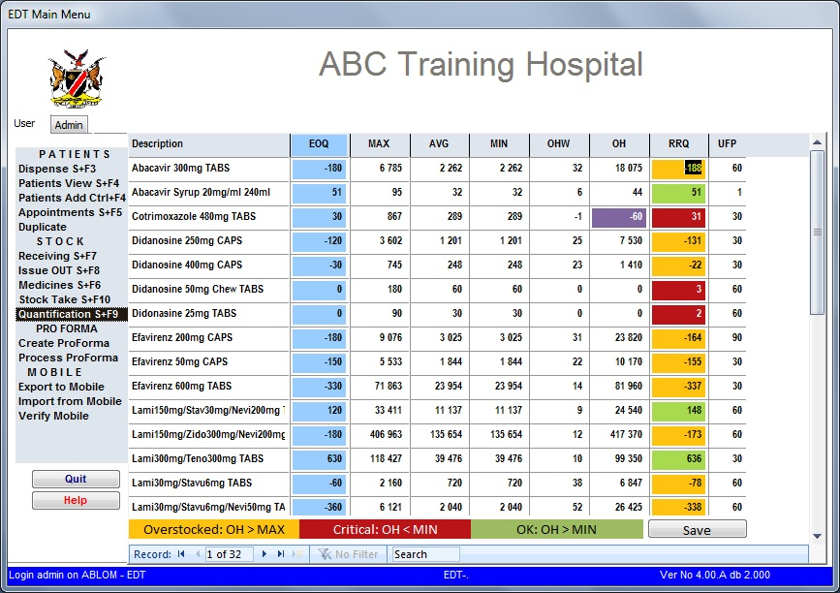

The Minimum, Maximum and Average consumption by month stock holding are pre-entered in the global long flags.

Definitions:

**EOQ** – this is the Economic Order Quantity. This quantity is based on the pack sizes as received by Central Medical Stores. This calculation rounds the Recommended Re-order Quantity (RRQ) either up or down to the nearest full box from CMS.

**Max** – this is the maximum stock on hand that the pharmacy should have. In accordance with the “Managing Pharmaceutical Stores – A Manual for Clinics and Health Centres” the maximum stock is set to 4 months.

**Min** – this is the minimum stock that should be at the pharmacy store. The stock on the shelf should not be allowed to go below the minimum stock. The minimum stock is set to be equivalent to 2 month’s consumption depending on space availability in the pharmacy store room.

**AVG** – this is the average consumption over a set period of months. The average consumption varies from facility to facility. In the above example, the average consumption is for a 12 month period and it is equivalent to the minimum stock.

**OHW** – This column shows the number of weeks the available stock will last based on the average consumption. OHW = **O**n **H**and **W**eeks.

**OH** – Quantities **O**n **H**and – the stock available on the system.

The negative OH for Cotrimoxazole 400mg TAB figure 3.14 above shows that dispensing was done against zero stock.

**RRQ** – this is the **R**ecommended **R**e-order **Q**uantities. This value is recommended as the user is expected to do a stock take before to identify expired medicines, breakages etc. Once a stock take has been done, the actual quantities (as they appear on the shelf) can be updated in the stock take menu (as discussed above).

The negative figure shows overstock and these are highlighted **yellow**.

Under stock is highlighted **red** and acceptable stock is highlighted **green**

# CHAPTER 4: MOBILE DISPENSING

## Preparing scanner for Outreach/IMAI

### Loading data on scanner

#### Cradle Scanner

Follow these steps to load your patient data from the computer / EDT onto the scanner. Please note that only active, In-Transit, Transferred In and Restart patients will be loaded onto the device. Transferred Out, LTFU, Deceased and Stopped by Physician statuses are not loaded.

In order to double check your patients before loading onto the device you must run the “Number of Patients” report for that outreach site and check the patients in the respective statuses drill buttons. In EDT patient view you can change the statuses to the correct status. You do not need to do these steps if you are sure your patients at the outreach site statuses are correct.

**Scanner**

1. Put scanner into cradle and switch on. The following screen will appear on the display.

**Figure 4.1**

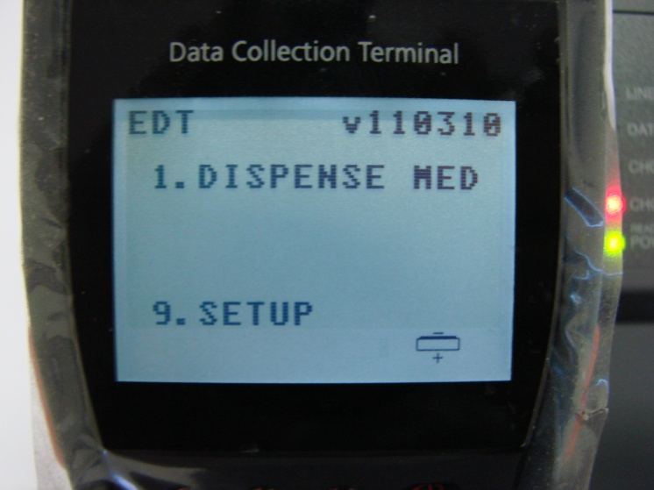

1. Select option 9 “SETUP” to get to the screen with options 1 -4. (Figure 4.2 & Figure 4.3).

**Figure 4.2 Figure 4.3**

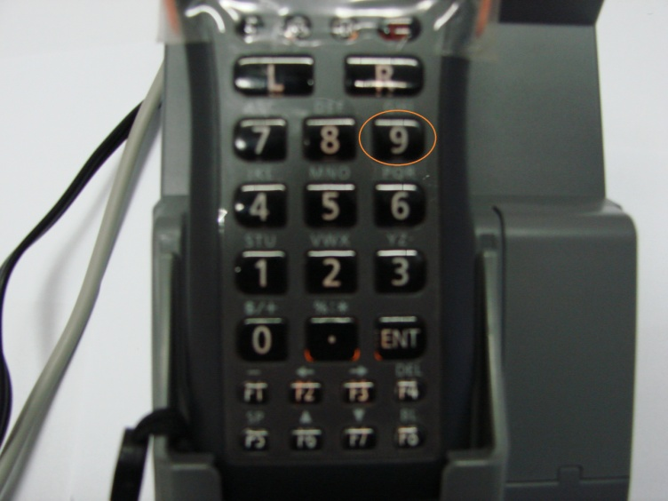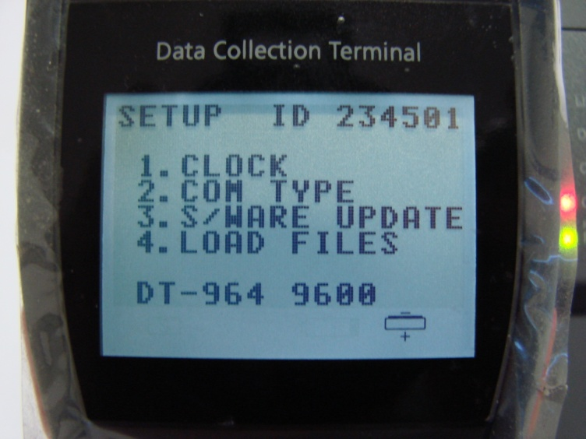

1. Select 4 – “Load Files” to load the files onto the scanner. The screen (Figure 4.5) that read “FILE DOWNLOAD – PLACE IN DT-964” will appear. At this stage you place the scanner in the cradle and continue the next steps on your computer.

**Figure 4.4 Figure 4.5**

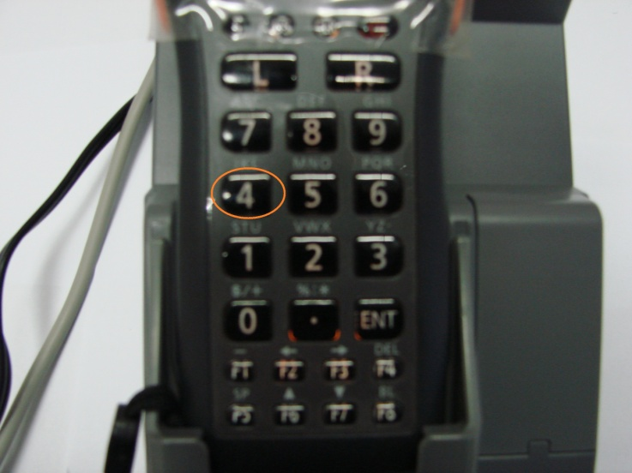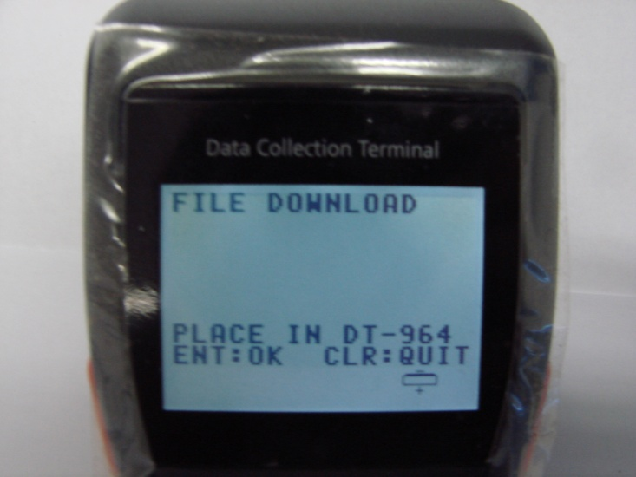

**Computer**

**Please note:** These steps have to be followed before pressing “ENT” on the scanner.

1. Go to the “Export to mobile” menu in EDT (Figure 4.6).

**Figure 4.6**

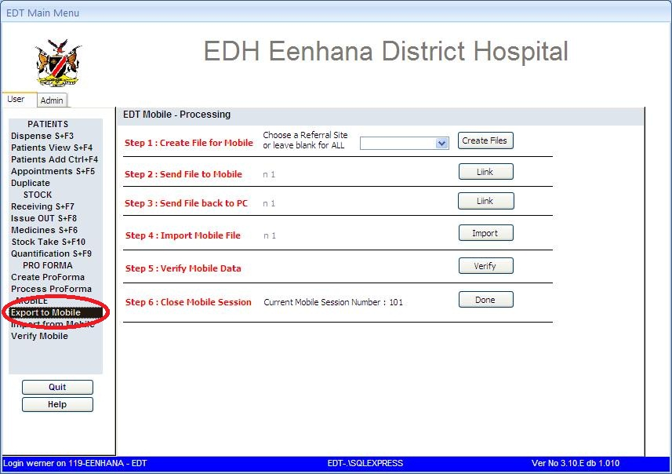

1. Select the outreach site from the drop down menu (Step 1, Figure 4.7), or alternatively leave it blank to load all the patients in the database with the statuses described above and click on the button “Create Files” (Step2, Figure 4.7).

“Note: You can leave it blank if you might be expecting some of the main facility’s or another outreach site’s patients to show up at the outreach site you are visiting.”

**Figure 4.7**

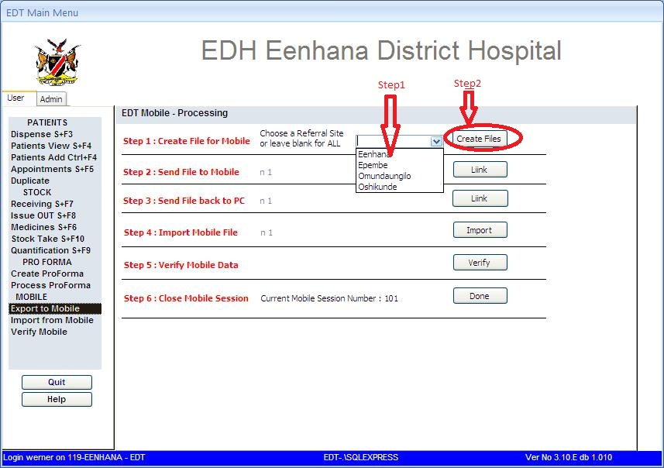

1. Click “OK” to confirm the files PAM and STH created and proceed to Step 2. (Figure 4.8)

**Figure 4.8**

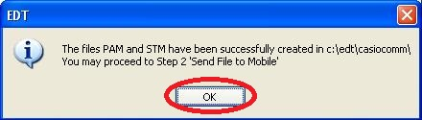

1. Click on the “Liink” button next to Step 2 (Figure 4.9). This will open the communications screen described below.

**Figure 4.9**

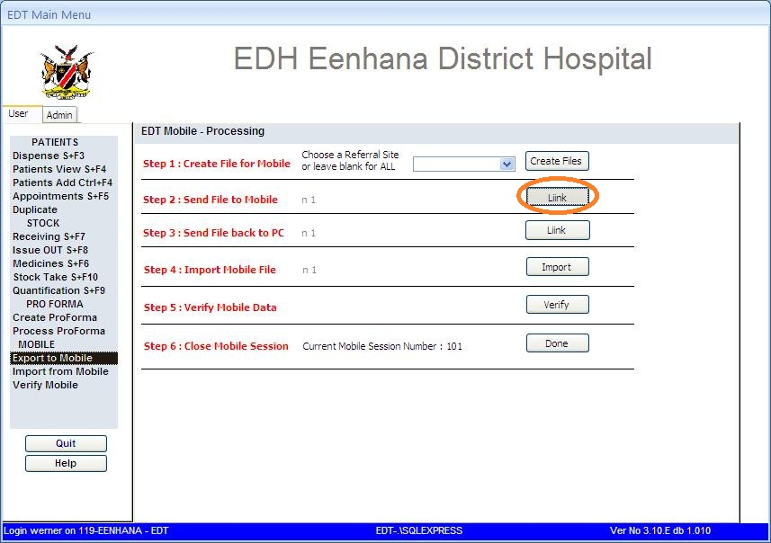

1. A thin “Comms by PDM” screen will appear on your computer screen (Figure 4.10). Only when this screen appears on your screen do you press “ENT” on your scanner (Figure 4.11). When this screen open continue the steps on the scanner.

**Figure 4.10**

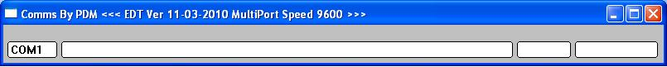

**Scanner**

1. Press “ENT” to continue on the screen for ‘File Download’ (Figure 4.11 & Figure 4.12).

**Figure 4.11 Figure 4.12**

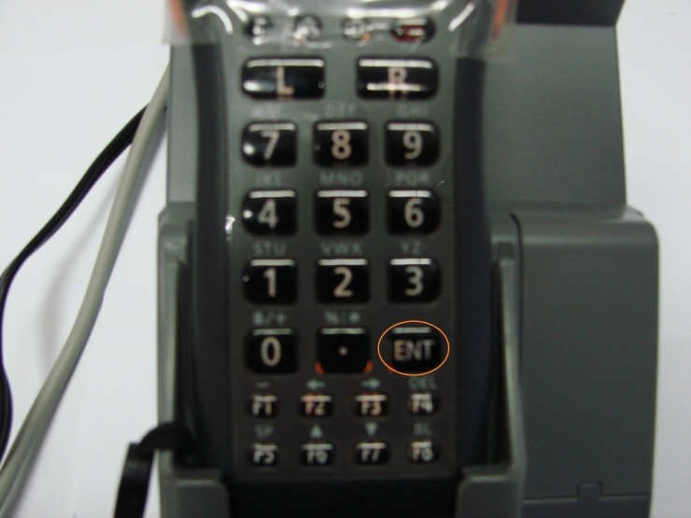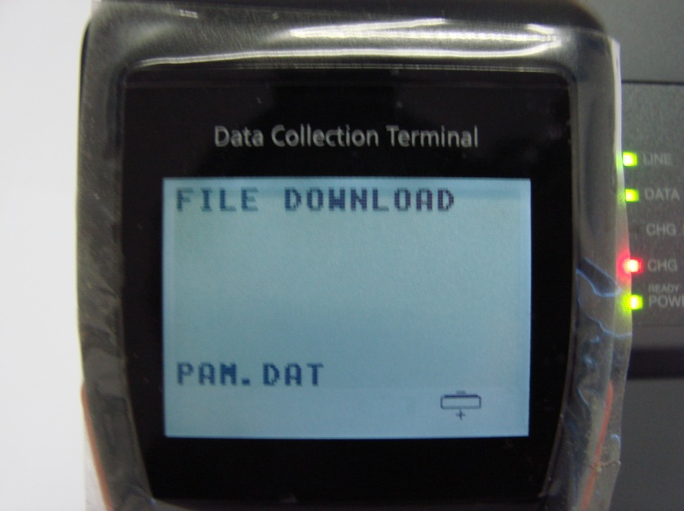

1. The scanner will show “FILE DOWNLOAD” and show the files being downloaded (PAM.DAT, STH.DAT and PWD.DAT) in the “Comms” screen you will see the progress of the transmission (Figure 4.13).

**Figure 4.13**

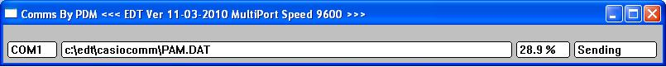

1. The menu on the scanner will return to options 1 -4 (Figure 4.3). Press “CLR” on your scanner to return to the main menu which shows “1 – Dispense medicine and 9 – Setup.”(Figure 4.14 & Figure 4.15)

**Figure 4.14 Figure 4.15**

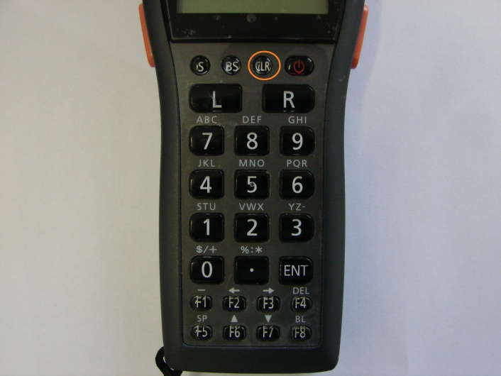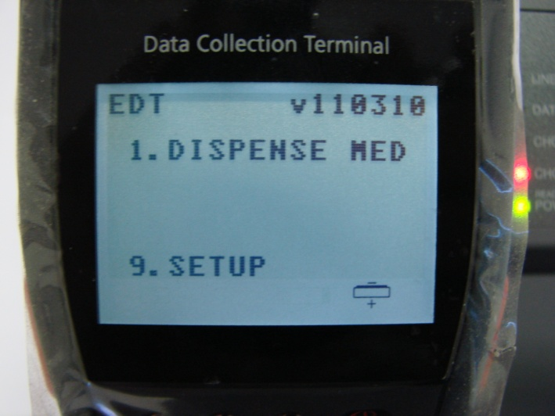

1. Switch off scanner and remove it from the cradle and take with you to the outreach site.

**Computer**

1. Close the comms screen when it shows “SUCCESS” (Figure 4.16). This screen confirms successful loading of data onto the scanner.

**Figure 4.16**

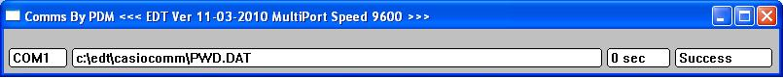

1. The person remaining at the pharmacy can now continue dispensing to patients.

#### Bluetooth Scanners: Loading Data on Scanner

1. To load and unload files using the Bluetooth scanner is almost the same as loading the files with the serial scanners. The section for creating the files on the computer should be done first. Once the files have been created follow the steps described below to establish the connection to the computer.
2. Click on the “Liink” button on Step 2 on the Export to Mobile screen. Once the communications screen (Figure 4.17) is open select option 4 on the scanner. This will list the stations set up on the scanner. The default station name for the facilities using Bluetooth scanners is “Airlive”.

**Figure 4.17**

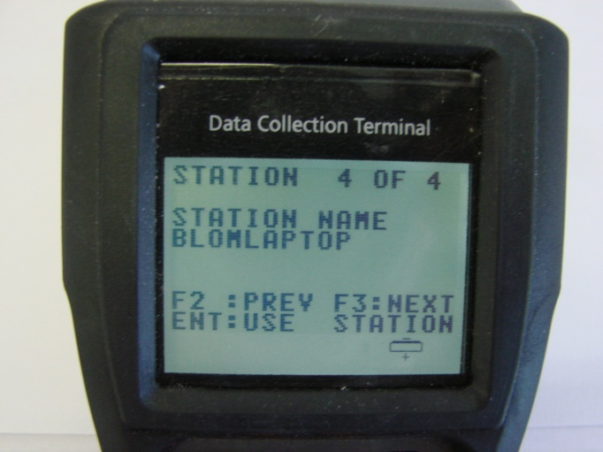

1. The current station name should appear on the list. If not, use the F2 and F3 buttons to scroll through the station until you find the Airlive station.
2. Press “ENT” to use the station displayed. The scanner will connect to the station and the download of the files will start immediately after the connection is established (Figure 4.18).

**Figure 4.18**

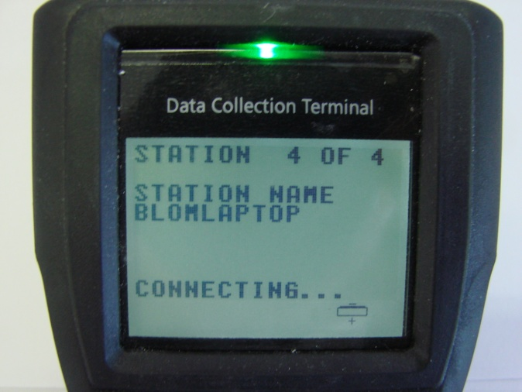

1. When the downloading is finished the scanner can be taken to the outreach site.
2. The dispensing on the Bluetooth scanners is exactly the same as that on the serial scanners.
3. The upload of files is done exactly the same way as with the serial scanners. The only difference is the step to put the device into the cradle is replaced with selecting the station as described in Steps 3 and 4 above.

### Dispensing on Mobile Scanners

1. Press 1 “Dispense medicine”.(Figure 4.17)

**Figure 4.17**

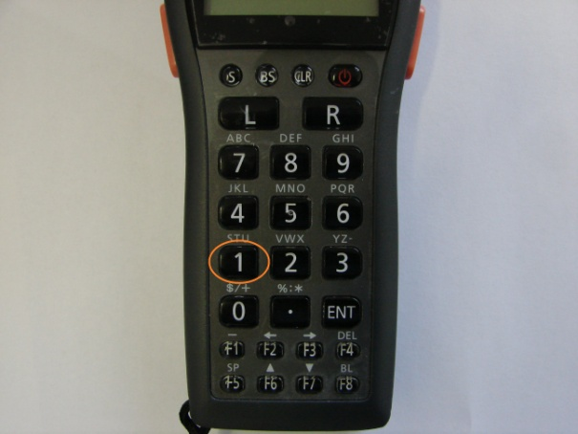

1. Put in the password – 1234 – and press “ENT” (Figure 4.18 & 4.19).

**Figure 4.18 Figure 4.19**

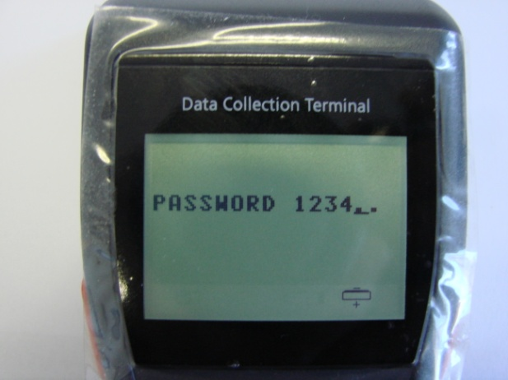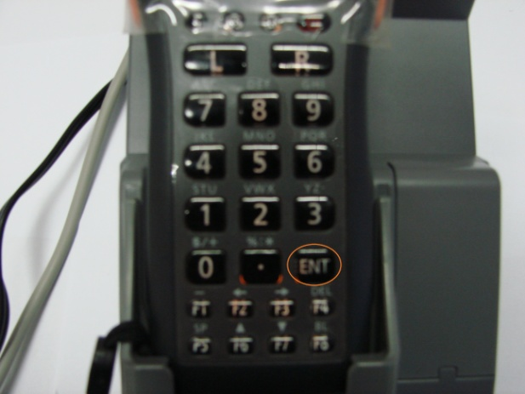

1. Type in the ART No of the patient obtained from the patient passport (Figure 4.20) and press “ENT”.

**Figure 4.20**

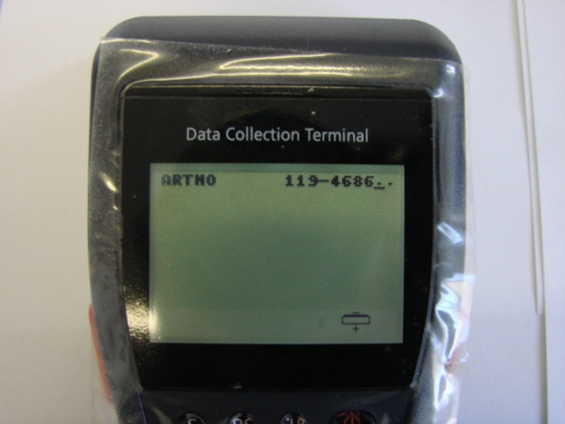

1. Check if it is the correct patient by comparing the ART No and the regimen with that in the passport. (Figure 4.21)

**Figure 4.21**

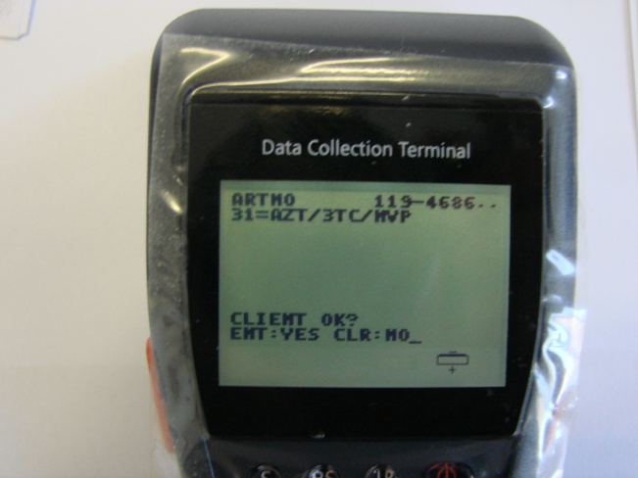

**Note:** No names are stored on the mobile scanner. Press “ENT” if the information is correct. If the regimen is different please note this patient no. in order to correct it when importing data back to the computer. All changes are done on the computer in the facility and cannot be done on the scanner.

1. Enter the number of days you are dispensing to the patient. This is the number of days to his/her next appointment (Figure 4.22 & 4.23). Press “ENT” to confirm if the number of days is correct.

**Figure 4.22 Figure 4.23**

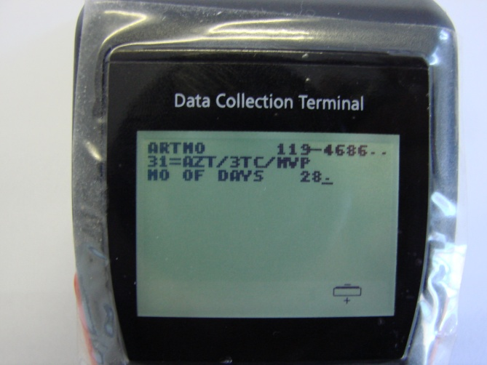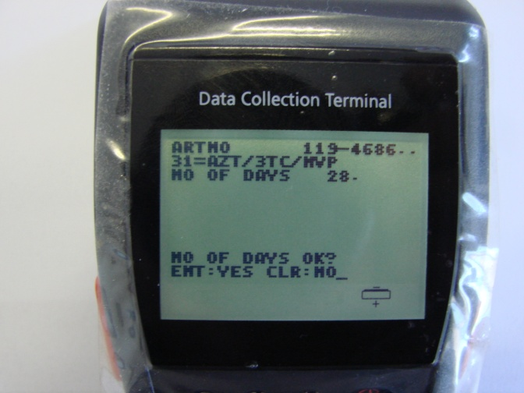

1. The next step is to enter the medicines you are dispensing (Figure 4.24). The scanners now require the medicine code to be entered. Facilities are provided with cheat sheets which contains bar codes of the medicines. The sheets can also be printed at the facilities from the medicines menu. You use the scanner to scan these bar codes thus you do not need to enter the codes manually. The scanner has 4 buttons that can be used for scanning; the user can use the button he/she is most comfortable with. The 2 buttons on each side of the device and the two buttons on the keypad marked “L” and “R” respectively. You hold the scanner upright and press one of these buttons and point to the bar code.

**Figure 4.24**

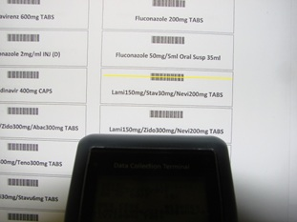

After scanning the medicine you will see a screen that list the medicine you have scanned. Confirm that the medicine scanned is correct by pressing “ENT” (Figure 4.25).

**Figure 4.25**

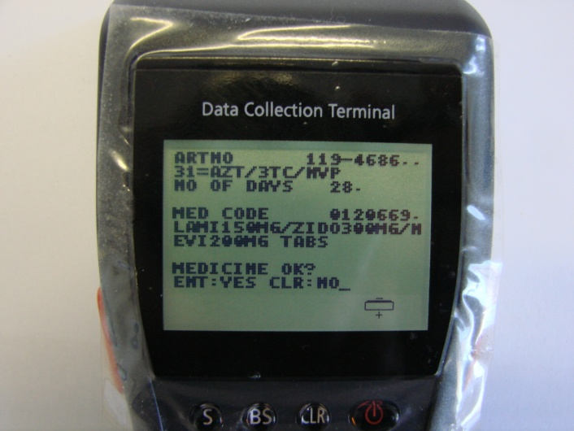

1. The next step is to enter your pill count and press “ENT”. Number of pills the patient still have left over from the previous dispensing. (Figure 4.26). Press “ENT” to confirm the pill count is correct (Figure 4.27).

**Figure 4.26 Figure 4.27**

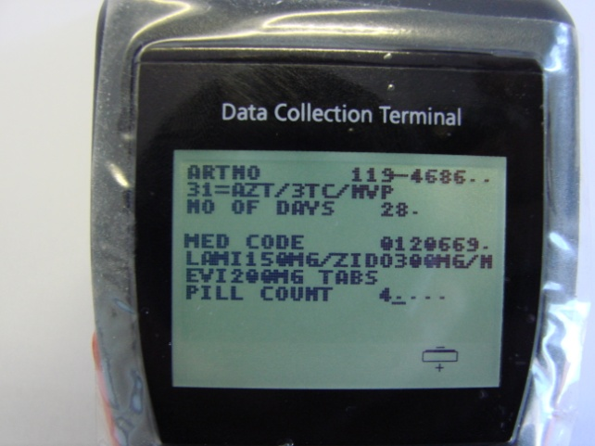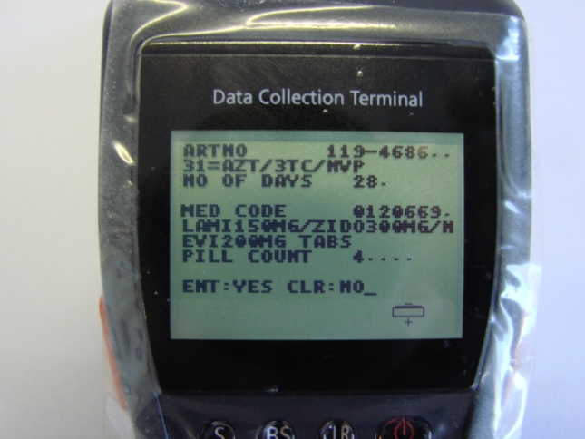

The next step is to enter the quantity you are dispensing (number of tablets) to the patient and press “ENT”. This depends on the number of days you are dispensing and the dosage prescribed by the doctor (Figure 4.28 & 4.29). Press “ENT” to confirm that the quantity dispensed is correct (Figure 29).

**Figure 4.28 Figure 4.29**

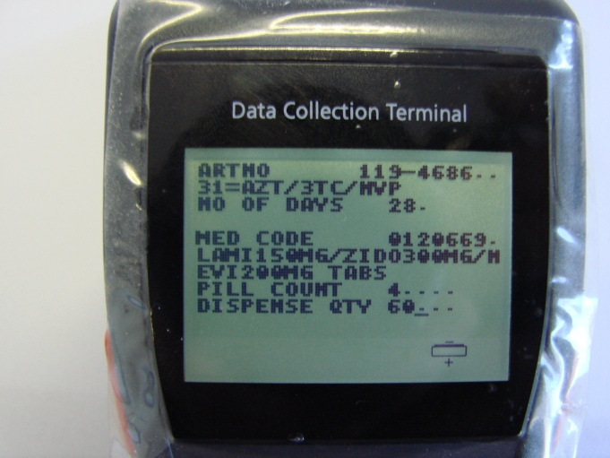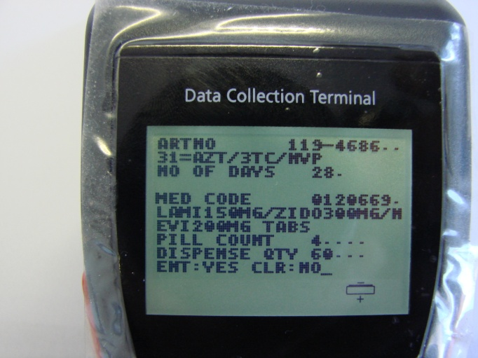

1. The screen of the device will now return to where you enter the medicine code. If you have more than one medicine to dispense to the patient, repeat steps 5 to 8 for the next medicine.
2. To continue to the next patient, press “CLR” two times to reach the screen to enter the ART number of the next patient and continue dispensing following the steps described above.

### Transferring Dispensing Data to computer

Upon returning from outreach you need to send the dispensing data done at outreach to the computer in order to update patient records on the EDT.

**Scanner**

1. On the main menu screen you will see the option number 2 “SEND DATA” now appears below “1 – Dispense Medicine”.(Figure 4.30). This means that data are currently stored on the device. **Note:** You will not be able to upload data again on the scanner until you have downloaded the existing data to the computer.
2. The first step in transferring data to the computer is to establish a connection between device and computer. Put the scanner into the cradle. Press 2 and enter the password (Figure 4.31) and press “ENT”.

**Figure 4.30 Figure 4.31**

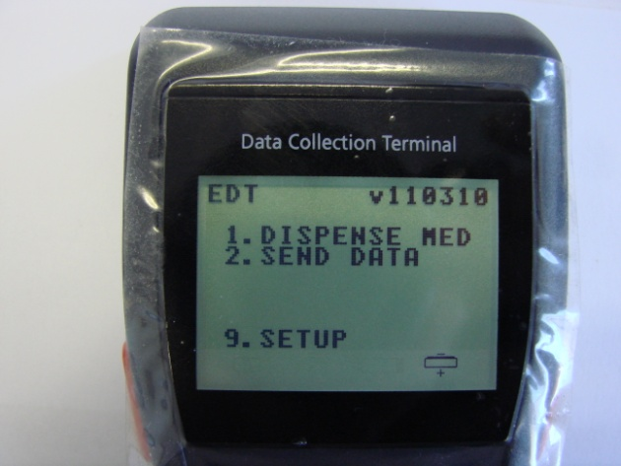

The screen for placing device in DT-964 will now appear (Figure 4.32).

At this point before pressing any buttons you move over to the computer.

**Figure 4.32**

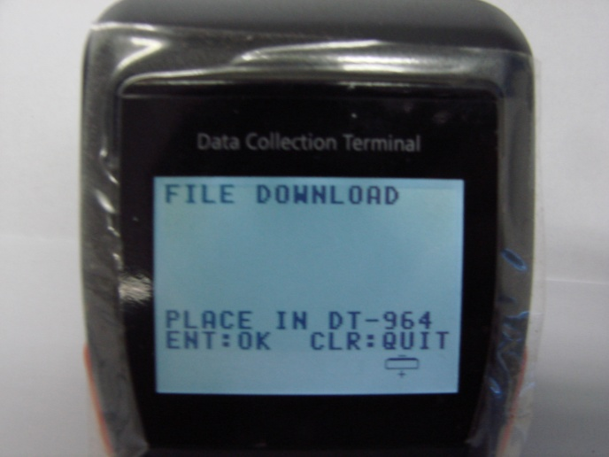

**Computer**

1. On the computer, go to “Export to Mobile” menu in the EDT (Figure 4.33).

**Figure 4.33**



1. Click on “Liink” next to Step 3 – Send File back to PC. The following windows will appear on your screen as seen in Figure 4.34 and 4.35.

**Figure 4.34**

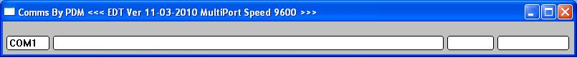

**Figure 4.35**

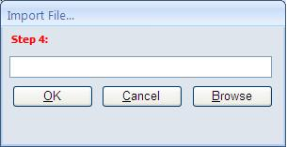

1. Press “ENT “on the scanner. The scanner will now send the file to the computer and on the computer it will show receiving files.
2. The comms windows will now show successful transmission (Figure 4.37). You will notice in the window that the filename of the file transmitted is a number.txt file. This number is unique for each device and differs for each facility. When this screen shows Success on the right the information has successfully moved to the computer. The option 2 – Send Data on the scanner is no longer visible. You can close this window and move on to the next window seen in Figure 4.38.

**Figure 4.37**

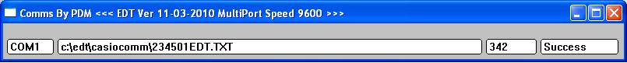

1. Click on the “Browse” button (Figure 4.38) that will take you to the select file to import screen (Figure 4.39).

**Figure 4.38**

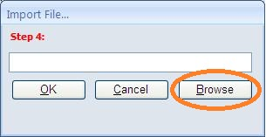

**Figure 4.39**

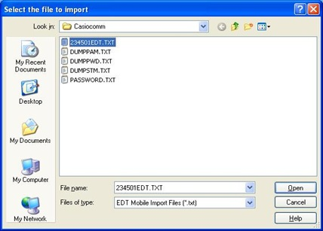

Select the file which read ‘number’EDT.TXT. This file is the same file copied from the scanner in step 7 and click on “Open”.

1. The file name and path will appear on the Import File window (Figure 4.40). Click on OK to continue with the import.

**Figure 4.40**

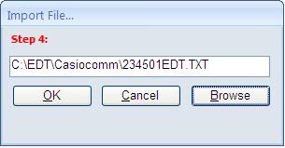

1. Click on OK to confirm the import (Figure 4.41).

**Figure 4.41**

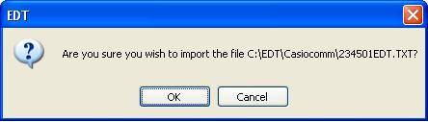

1. The following windows show you the status of your import (Figure 4.42 & 4.43). Please wait for these processes to complete.

**Figure 4.42 Figure 4.43**

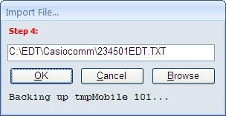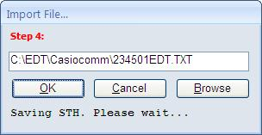

1. Click on OK to confirm successful import of data. The number does not reflect the number of patients dispensed to but the number of medicines dispensed. For each medicine dispensed a record is kept which include number of days dispensed, pill count on that specific medicine and quantity dispensed which is linked to the ART number.

**Figure 4.44**

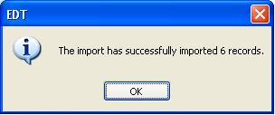

The EDT main window will appear after the import and you have to go back to the “Export to Mobile” menu (Figure 4.45).

1. Move on to the next step which is step 5 – Verify Mobile Data. Click on “Verify” next to step 5.

**Figure 4.45**

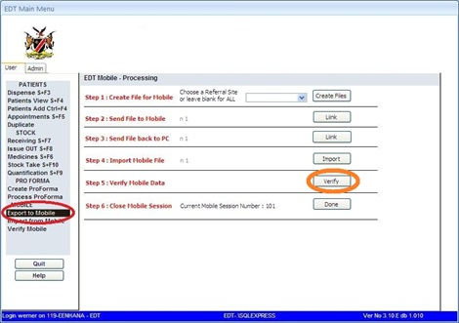

1. The verification window will now appear. On this window you scroll through all the records and make changes where necessary. This you do when you have marked patients that are on the wrong regimen etc. (Figure 4.46)

**Figure 4.46**

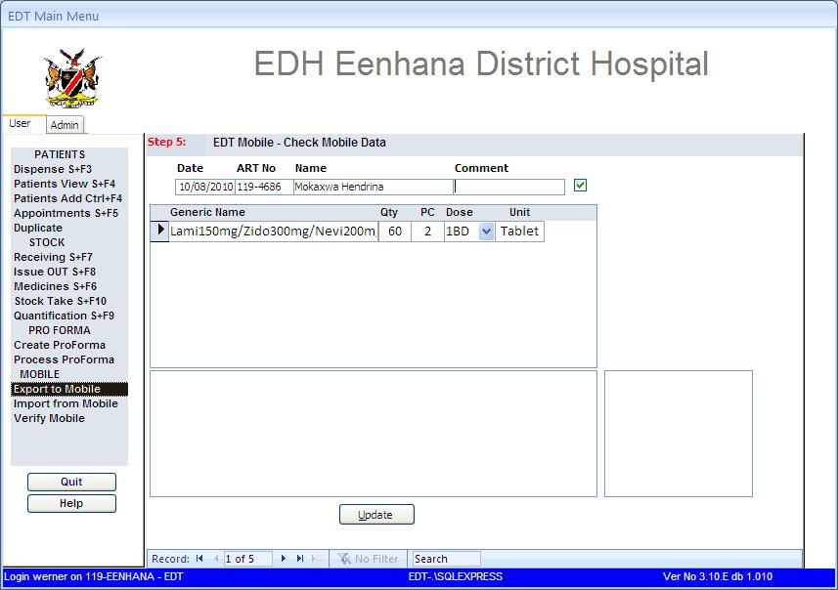

1. Once you are finished verifying the data from the mobile device click on the “Update” button at the bottom. The window to accept all mobile dispensing data will now appear. Click on OK (Figure 4.47).

**Figure 4.47**

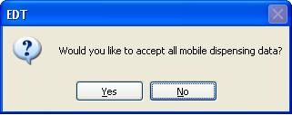

1. After the acceptance of the data a confirmation window will appear. This window allows you to print an audit trail of the dispensing done on the scanner. You do not need to print the audit trail. Click on NO (Figure 4.48).

**Figure 4.48**

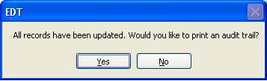

1. To validate that the records have been updated you can go to the dispensing history of any patient dispensed on the mobile device. On the history page it will show a pro-forma number that is equivalent to the mobile session number (Figure 4.49).

**Figure 4.49**

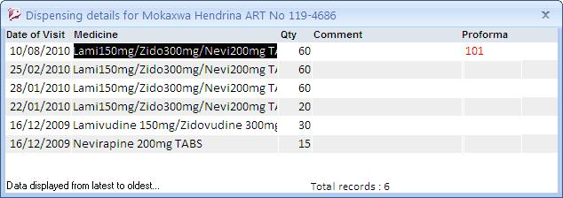

# CHAPTER 5: REPORTS

The system produces various types of reports. Each report is described below. Please note that the report list is not exhaustive, more reports can be designed if needed.

The report menu does not appear on the main menu. It appears separately as a reports icon on the desktop.



Report icon on the desktop

Double click on the reports icon on the desktop. The report screen will appear (see Figure 5.1).

**Figure 5.1**

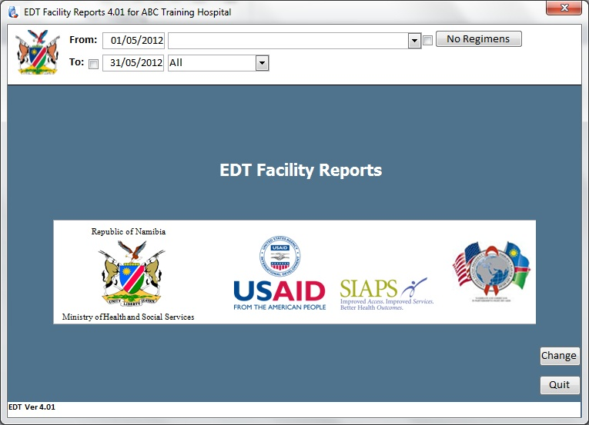

To access any of the reports, click on the drop down arrow on the right and select the report to be printed.

The period for reports is for the previous reporting period by default 30 days. To select a different period click the radio button next to “To”. You will now be able to select different dates from calendar drop downs or type in the required date selection.

All reports can be exported to Microsoft Excel and saved.

**New Patients Started by Regimen –** Shows all patients Therapy Start within the date range, remembering that only valid PAMART numbers are thus counted. Incomplete numbers and abandoned take-on are excluded.

**No of Pick-ups by Patient –** this report displays the number of pick-ups in a month grouped by patient status, regimen, and age group. The statuses are Routine Refill, In-Transit, Restarted and Transferred-In. This report shows the number of patients served and not the number of scripts dispensed.

**All Patients** – this report shows the cumulative number of patients by status; including new patients started this period.

**All Status Changes –** Showing all patients who had status changes recorded in the date range.

**All Switches –** Shows all patients who had switches recorded in the date range.

**Number of Patients –** Grouped by Adult and Paediatrics – This report gives a number of patients by regimen whose status changed to one of the statuses displayed during the indicated period.

**Lost to follow up at 12 months (EWI02) –** Number of patients initiating therapy 12 months ago who have not been seen at pharmacy for 90 days or more since date of last visit**.**

**Patients retained on ART 12 months (EWI03) –** Patients retained on ART 12 months after initiating on an appropriate first line regimen**.**

**Items Presumed out of stock  –** Presumed stock outage as at date of stock. Items on the list were counted with a zero value during stock take.

**Current Stock Balance –** This is the stock balance as on this instant. It is not taking into account the selected date range.

**Medicine dispensed by Period –** medicines dispensed for the selected period

**No of Scripts per Day –** This report indicates the number of scripts dispensed per day. Also shows workload.

**Patients Late for appointment –** Patients who collected medicines in the date range, but who were late for the appointment by number of days. Patients who did not collect medicines are excluded

**On time ARV pickup (EWI4) –** Patients who collected medicines on time (less than 4 days after date of appointment)

**Patients running out of ARV** – During the selected period, how many patients who came for a refill had run out of any ARV medicine by the time of refill.

**Patients Adherence –** Shows percentage patient adherence for facility.

**Facility Average Adherence –** Shows facility adherence in graph format

**Patients Not running out ARV –** Patients who had medicine at the time of their refill.

# CHAPTER 6: ADDITIONAL INFORMATION

**A. Printer Setup**

**Windows configuration:**

1. To configure your printer for the correct paper size for the labels, click on “Start” on your Windows Task Bar. As shown in Figure 5.5 below.

**Figure 6.1**

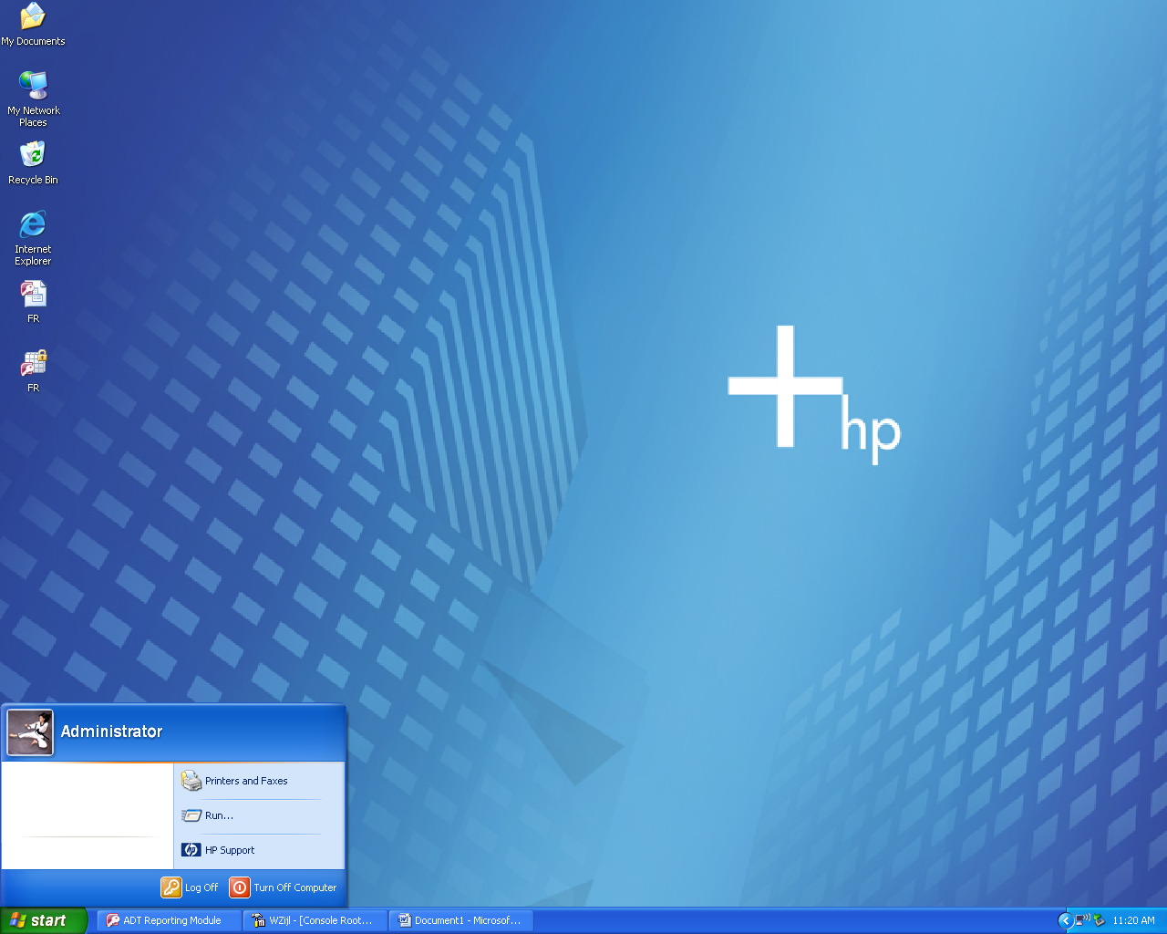

1. Click on “Printers and Faxes”
2. In the main window, click on “File” and select “Server Properties”, as shown in Figure 6.2 below.

**Figure 6.2**

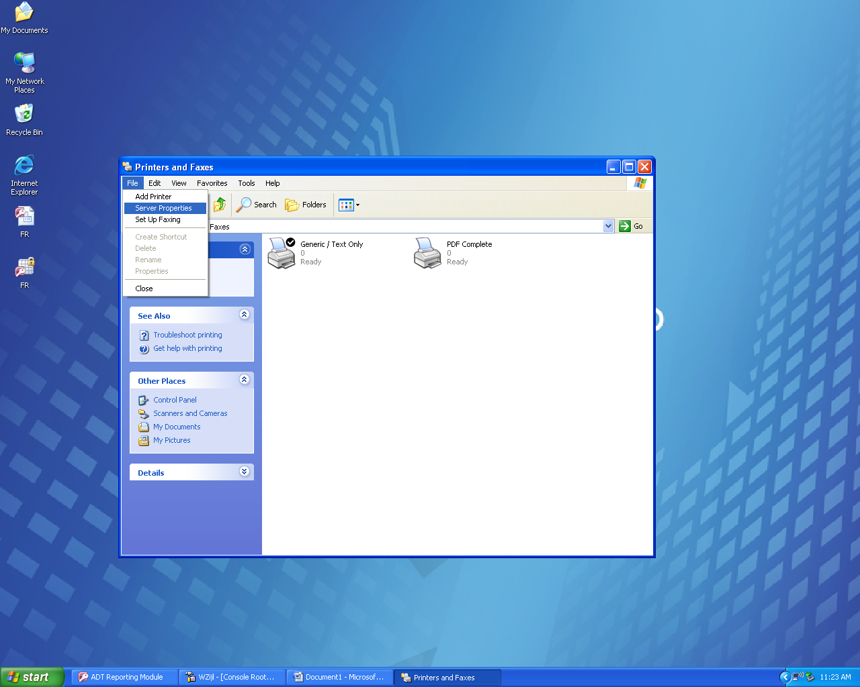

1. On the Print Server Properties screen (Figure 6.3) click in the “Create a new form” check box. Name the form “MSH” and set the width and height according to the parameters.

**Figure 6.3**

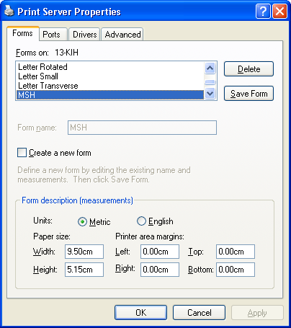

1. Click on “Apply” and then “OK”, to accept settings.

**B. Changing a patient record**

To change record information for patients, under “Patient View”, click on “Edit”. A pop up will appear informing that you are now in edit mode (Figure 6.4).

**Figure 6.4**

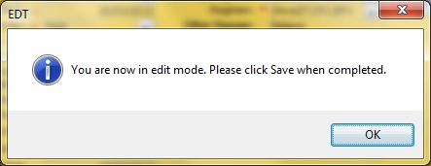

The color of the screen change and the user is now in edit mode. The user can change any field on the screen except for the ART number. In Figure 6.5 the language was changed from English to Oshivambo.

**Figure 6.5**

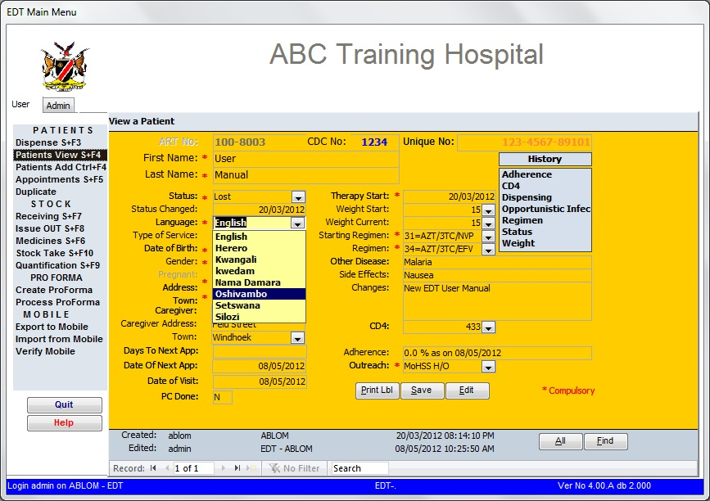

Click on “OK” to acknowledge changes (Figure 6.6).

**Figure 6.6**

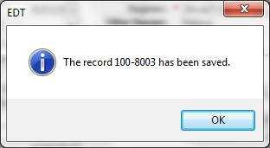

**C. Creating a proforma for Outreach**

Select the tab written; Create proforma as shown in figure 5.20 below.

**Figure 5.20**

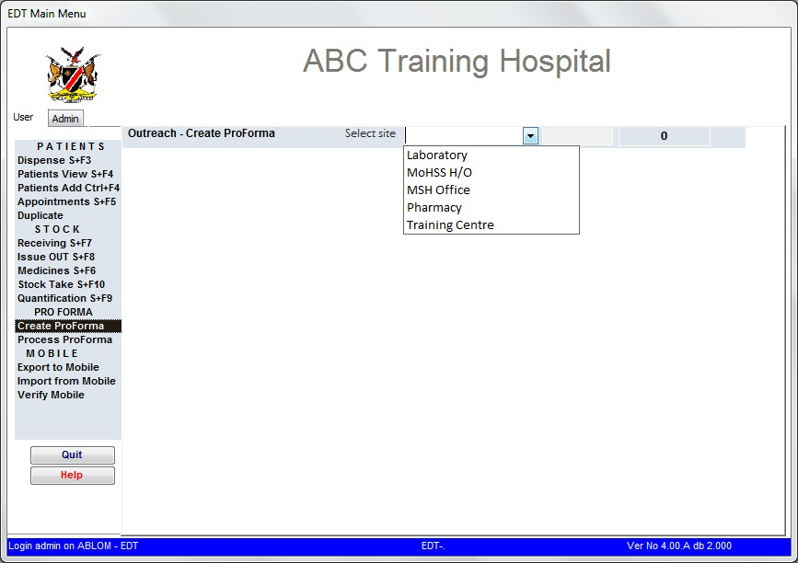

Select the outreach site using the drop down button on top of the screen. Once the site is selected, select the date when you are going to dispense to clients at the outreach site. The system asks for confirmation to proceed as shown on figure 5.21 below.

**Figure 5.21**

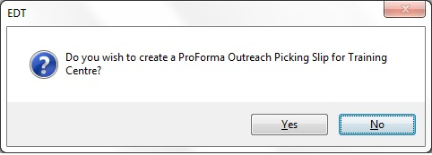

Upon confirmation, the list of all the patients whose appointment date falls on the date chosen will appear but since only one record appears at a time, you need to scroll through the list using the scrolling buttons at the bottom of the screen. As indicated on figure 5.22 below, for each patient, the regimen prescribed and the medicines attached to that regimen are displayed and the user should indicate the quantities of the prescribed medicines.

**Figure 5.22**

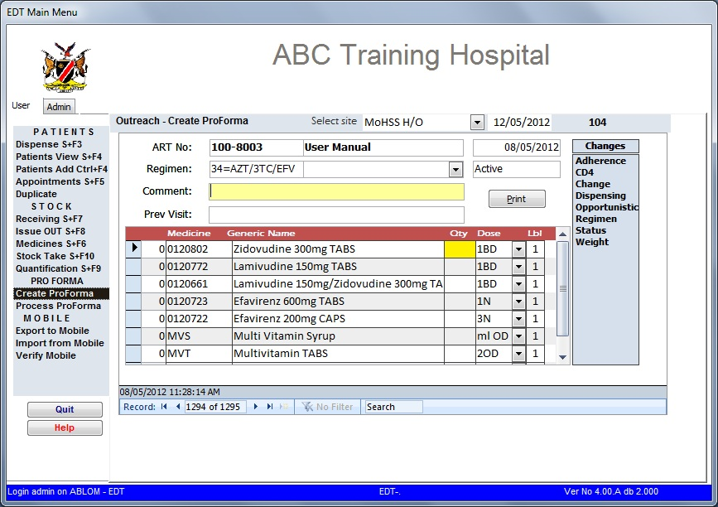

After the quantity for each medicine has been entered before proceeding to the next medicine, the label is automatically printed and the figure 5.23 shown below appears briefly on the screen.

**Figure 5.23**

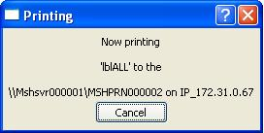

After all pro-forma dispensing is done, click on “Print”, and the picking list will be printer on A4.The picking list that the user eventually carries to the outreach site is developed in the background screen as shown in figure 5.24 on the next page.

**Figure 5.24**

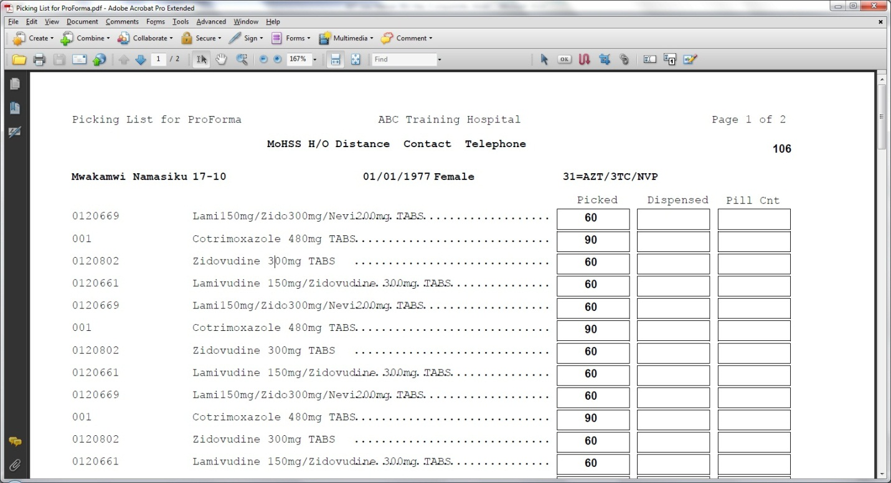

## C. Processing a pro-forma

After attending to the patients at the outreach site the user should process the proforma of all the patients that were attended at the site by clicking on the “create pro forma” button (Figure 5.25).

**Figure 5.25**

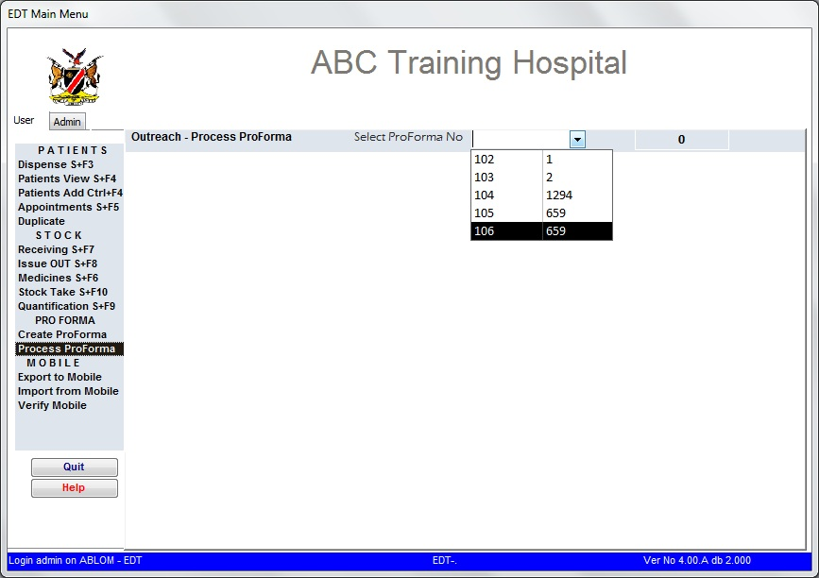

After selecting the number of the proforma, the screen shown in figure 5.26 appears.

**Figure 5.26**

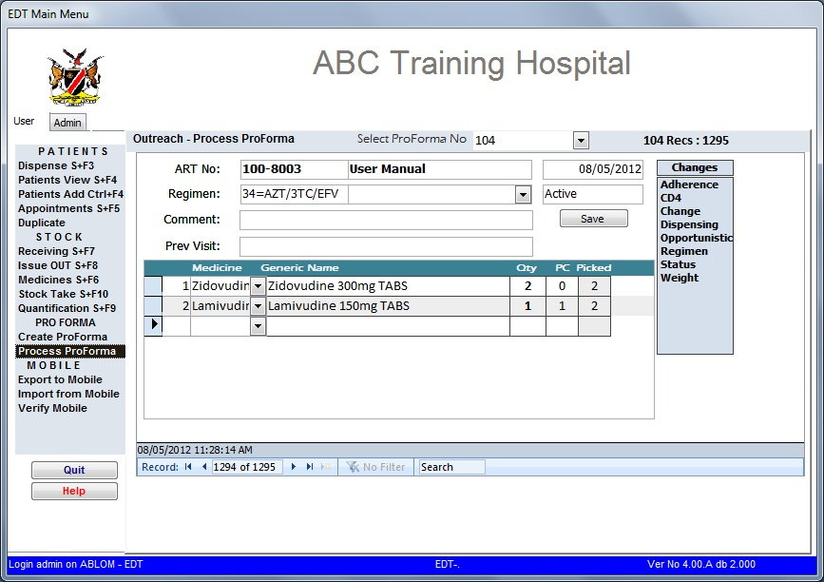

For every record of the patients that received their medication, indicate the quantity picked and pill count and then click the save button. For the patients whose details were in the proforma and never came to pick their medicines, put a zero besides that medicine for the record to be cancelled. For the cancelled transactions, the confirmation window shown on figure 5.27 below will appear.

**Figure 5.27**

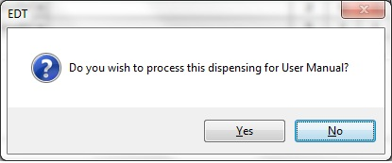

The proforma processing step is similar to the normal dispensing process and the confirmation window for inserting the dates for the next visit as shown in figure 5.28 below appears.

**Figure 5.28**

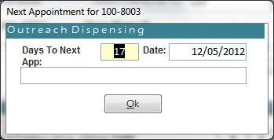

The dispensing details for outreach patients contain the proforma number that was generated when the visit was conducted. See Figure 5.29 below.

**Figure 5.29**

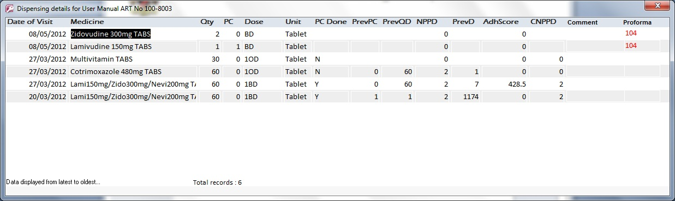

**G. Duplicates**

Duplicate patients are now accessible from the main menu screen. To check and mark patients as duplicates, click on the duplicate menu. Select the patients you want to mark by checking their dispensing history. The patient with the most or recent dispensing history is normally left as active and the one with no records or old records are marked as “Duplicate”.

**Figure 5.30**

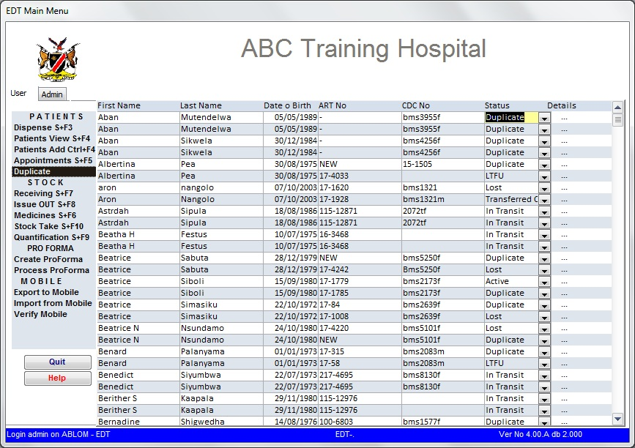

When you click on the “Details” (…) button the following screen appears where you check the dispensing history of the patient.

**Figure 5.31**

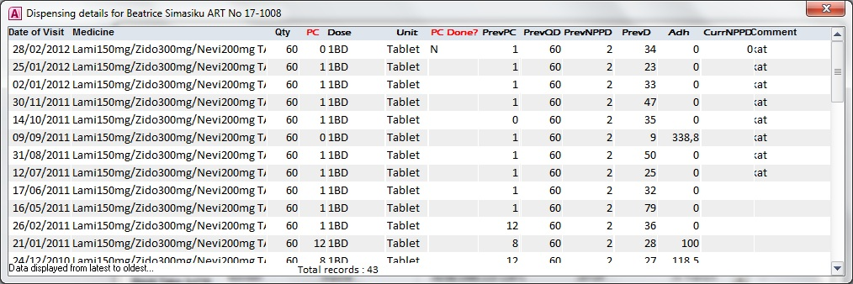

**Adding or Editing Usernames and Passwords**

1. **To add a new user.**
2. Under “Admin” click on Maintenance, select “Add or Edit Users.

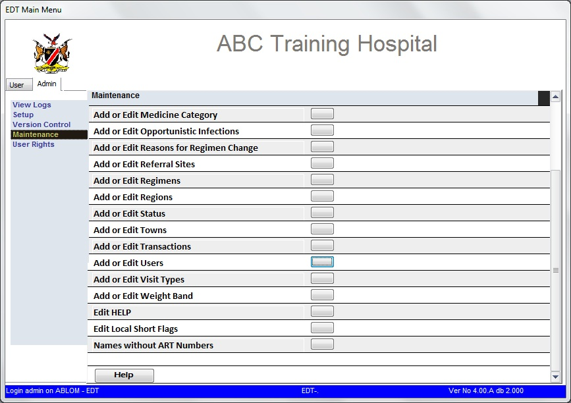

1. Click on “New Blank Record”, and enter the new users credentials – first name and surname – press ENTER (see Figure 2)

**Figure 2**

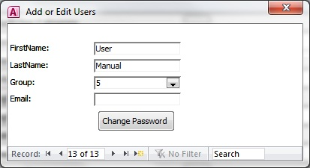

1. By default the password will be set to the user’s surname as shown in Figure 3. Click on “OK” to acknowledge the new user and password

**Figure 3**

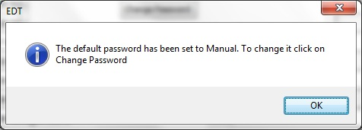

1. The new user is now added.

(Please take note NOT to edit existing users with the new user credentials, by clicking on the new record button first)

1. **To change a password**
2. Follow the same path as to adding a new user.
3. Select the user of which the password needs to be changed. Click on the   
   “Change Password” button. You are required to enter the existing password (Figure 5) for the user before you can enter a new password (Figure6).

**Figure 5**

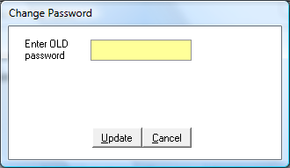

**Figure 6**

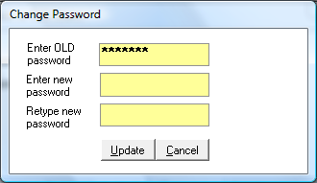

1. If you do not have a old password, or the user has forgotten their password, rather create a new user with a different first name for that user.

(Please do not enter same first name with a different password, “Invalid password errors will occur at “Login”).